Uploading your documents – how to guide

Scientific Expeditions – Amazon +10 Initiative
05 April 2024

Uploading your documents – how to guide
- Fill out The British Council Additional Information form in full and convert it into a pdf file.
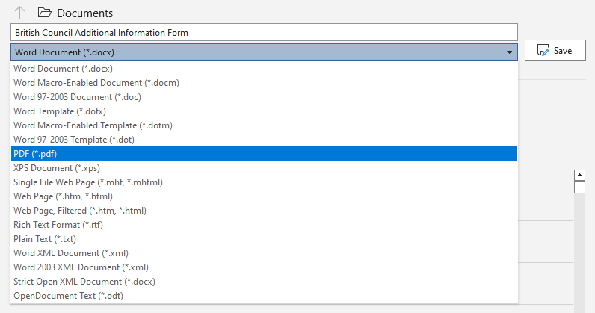
- Open The British Council Additional Information form in Adobe Acrobat Reader
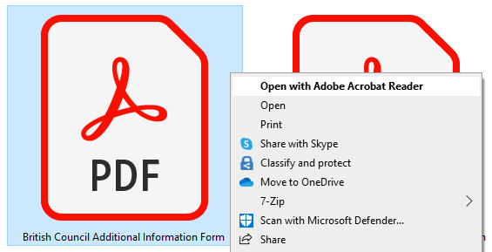
- Click on “Comment” at the vertical navigation bar on the right-hand side of the document.

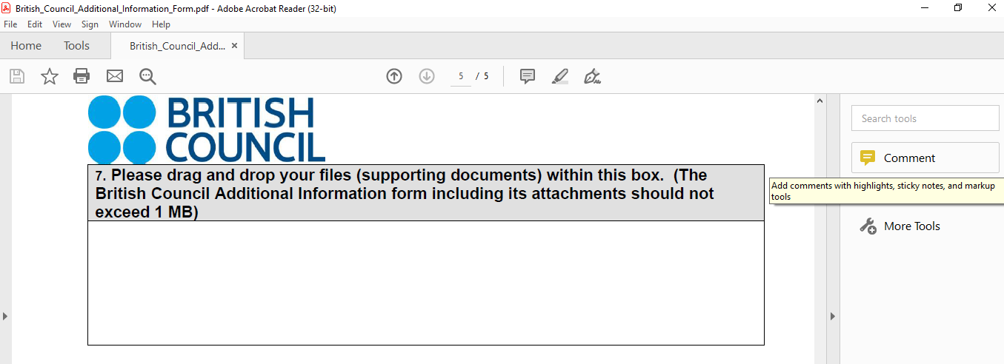
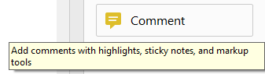

- On the new horizontal navigation bar displayed immediately above the document, select the clip with a + sign “Add a new attachment”.

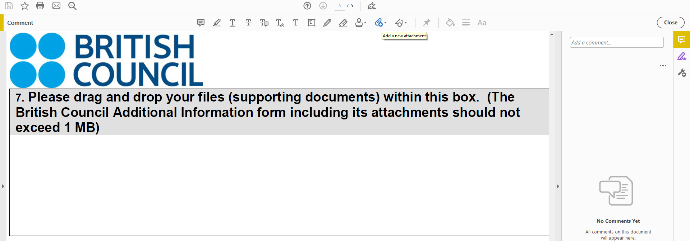

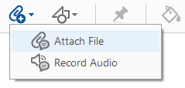

- The image of a pin will be displayed.

- Click into the box below and you will be able to select the pdf file to insert. Repeat this procedure for each of the required documents. All of them should be in pdf format.
