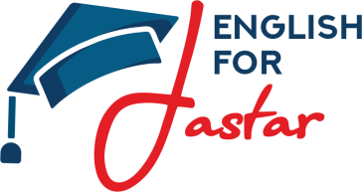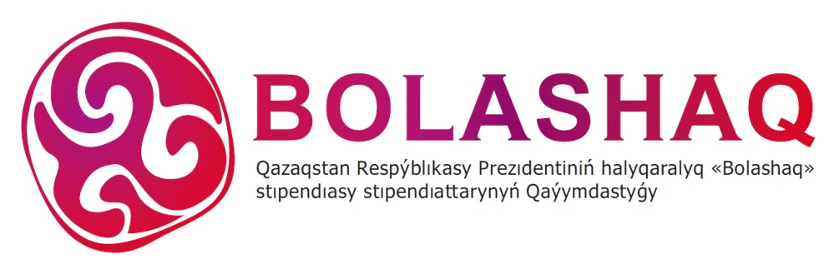
The Project «English for Jastar»

One of the most effective methods of learning foreign languages is direct communication with native speakers. Nevertheless, many schools in Kazakhstan cannot afford foreign teachers. Therefore, it was proposed to attract volunteers to schools, which have no investments to afford native English speakers. The role of each volunteer is to increase the motivation of schoolchildren of the secondary schools of Kazakhstan (rural areas) for studying foreign languages. At the same time, foreign volunteers will help to expand the outlook of pupils.
1. Project Organizators - Association "Bolashak", MK "Zhas Otan".

2. The aim of the Project - to create a system for attracting volunteers for the dissemination of English in all regions of Kazakhstan on an ongoing basis.

3. The social impact of the Project:
- improve the level of the English language of pupils;
- increase the motivation for learning English language;
- provide an access for learning English language in the regions of Kazakhstan.

4. Timing
№ | Stage | Time
1. | Implementation of the pilot project | 03/09/2018 - 03/12/2018
1.1. | Conducting introductionary sessions, trainings and  master classes for volunteers | 18/08/2018 - 31/08/2018
1.2. | Additional English courses | 03.09.2018 - 03.12.2018
1.3. | Holding of the closing ceremony, summing up, awarding certificates of volunteers and schoolchildren | 20.11.2018 - 03.12.2018

5.Within the framework of the Project implementation, the organizators:
Provide with: | Do not cover:
Accommodation of volunteers | International flight
Meals for volunteers | Payment for volunteers
Registration of visa documents
Medical insurance during the period of practice
Logistics for Kazakhstan
Conducting an adaptation week
Distributing volunteer package

6. Selection Process
- 1 stage - selection of the volunteers will be based on the CV of the candidates
- 2 stage - Skype interview with choosing candidates

7. Working hours
11:00 am to 04:00 pm
Not on weekends

8. Foreign volunteers will receive:
- teaching experience;
- working experience with children;
- cultural acquaintance with the new country and its customs;
- broadening of horizons;
- finding new acquaintances;
- establishing new professional contacts;
- provision of books;
- cultural program;
- certificates of this Project;
- souvenirs;
- learning new languages.

CV

Name __________________
Country_________________
Hometown_______________
City of residence (if different) ___________
Age ______________
Sex_______________
1. Academic Experience:

2. Professional Experience

3. Teaching Experience

4. Languages:

5. Skills

