Going Global Partnerships
Development of Teaching Excellence Framework (TEF) for Pakistan

Application Guidelines
February 2024

Going global partnershipS

Guidelines for Applicants

Call opens Friday 23 February 2024
Call closes: Monday 18 March 2024; 23.59 UK Time

Important Dates
Sr. No. | Activities | Date/Month
 | Call for proposals advertised in the UK and Pakistan | 23 February 2024
 | Deadline for submission | 18 March 2024
 | Evaluation of submissions completed | 1 April 2024
 | Contract to be signed | 15 April 2024
 | Project implementation starts | 15 April 2024
 | Expected completion of project | 15 March 2025

- Background
Pak-UK Education Gateway
The British Council in Pakistan and Higher Education Commission (HEC) Pakistan are working on a joint programme that aims to enhance the partnership between the higher education sectors of Pakistan and the UK. Key areas of collaboration under this umbrella framework are innovative and collaborative research, higher education leadership, quality assurance and standard-setting, distance learning, international mobility, and transnational education.
Pak-UK Education Gateway builds on existing collaborations between the UK and Pakistan that the British Council and Higher Education Commission has facilitated over the last fifteen years: from knowledge exchange and leadership development programmes to student and teacher training, scholarships, and research collaborations.
The project aims to develop Teaching Excellence Framework (TEF) for Pakistan to create a system to recognize and encourage excellent teaching in higher education universities in Pakistan.
- Rationale
The Teaching Excellence and Student Outcomes Framework (TEF) aims to assess excellence in teaching at universities and colleges, and how each higher education provider ensures excellent outcomes for their students in terms of graduate-level employment or for further study.

The TEF encourages universities and colleges to work with their students to develop a better student experience. It does this by measuring how well a university or college is performing in the areas that students care about the most: teaching, learning and student outcomes.

Under the Quality Assurance and Standard Setting thematic area of PAK UK Education Gateway project, both British Council and Higher Education Commission of Pakistan agreed to work on the Development of Teaching Excellence Framework (TEF) for Pakistan.

The TEF should be developed through a phased approach by collaborative efforts of involving best teachers from Pakistani Universities and Higher Education Institutions. For that matter, selected faculty members have already been oriented on UK’s TEF and implementation mechanism/modalities by the representatives from Sheffield Hallam University and Coventry University (UK). A post orientation survey was also conducted to have preliminary input on having TEF for Pakistan and results have been compiled.

These selected faculty members from Pakistan will be trained on TEF at UK and will work with the consultancy service provider during the development process.

- Outcomes
Through this project the British Council and the Higher Education Commission would like to invite full proposals from organization/institutes and Universities from the United Kingdom/consortium partners from Pakistan and UK including other international organizations/institutes in the higher education sector, which have relevant expertise and partnerships to work with UK and Pakistan institutes on developing teaching excellence framework to meet the following outcomes.

Stage I - Capacity Building of Pakistani Universities’ teachers during their visit to UK Universities/Governing bodies
- Engage Pakistani Faculty with key stakeholders to develop better understanding and to acquire information sources in UK w.r.t TEF.
- Provide necessary guidance to develop data collection templates.
- Facilitate data analysis and reporting.
- Accompanying Pakistani Faculty during their visits to TEF ranked universities/providers.
- Gain firsthand knowledge from the Pakistani Faculty on existing teaching practices in Pakistan.
- Facilitate Pakistani Faculty during the gap analysis and preparing proposal on TEF development for Pakistan.

Stage II - Development of TEF and Implementation at pilot universities in Pakistan
- Work in close liaison with Pakistani university teachers to develop thorough understanding of existing learning resources and student outcomes in Pakistani universities.
- Thoroughly review the parameters of “Pakistan Precepts, Standards, and Guideline for Quality Assurance in Higher Education (PSG-2023) – HEC” for its possible alignment with “to be” Teaching Excellence Framework for Pakistan.
- Conduct survey, that would require visits to universities in Pakistan, for data collection and to compile survey results in a report.
- Conduct in-depth review of proposal on TEF, already developed by the faculty, compare with collected survey data and fill the gaps, if any.
- Develop basic version of TEF for Pakistan in collaboration with selected university teachers and share with stakeholders for review.
- Perform a dry run of the developed TEF through the support of university teachers.
- Facilitate/guide pilot implementation of the newly developed TEF in ten (10) selected universities in Pakistan in minimum 1 to 2 academic cycles.
- Refine the developed TEF based on the outcome/feedback of pilot implementation.
- Explore future implications of HEC’s Online and Distance Learning (ODL) policy on TEF’s practicability and effectiveness.
- Develop TORs and associated material/documentation required for capacity building of universities around newly developed TEF for its effective implementation.
- Attending/participating meetings of project stakeholders
- Formal closure, including presentations to the Authorities/Committee for obtaining approval (s).

The entire effort can be of maximum 60 working days level of effort, subject to change, based on progress and administrative bottlenecks, if any. This includes work conducted remotely and with frequent visits to Pakistan, or the provider may stay in Islamabad during the contract period. This will also include visits to universities in different cities of Pakistan where travel restrictions to service provider may allow.

The contract will be issued by the British Council Pakistan, and it will include the information regarding work with the teams of British Council and HEC. The contract will be supervised by the HEC and British Council. All the reports/recommendations will be shared with HEC and British Council.

- Expected Deliverables

Specific deliverables are:

Deliverables | Outcome
- Assist Pakistani faculty during their  visit to UK universities and  developing proposal on TEF | - Pakistani faculty develops understanding of UK’s TEF  - Compile survey results  - Gap analysis report  - First draft framework on TEF for  Pakistan  - Work progress and input on subsequent activities.
- Visit to Pakistani universities and  TEF Development | - Modified version of TEF for Pakistani universities  - TEF aligned with PSG – 2023  - Work progress and update on  subsequent activities
- Pilot Implementation & Refinement of TEF | - Dry run of newly developed TEF conducted.  - TEF Implemented at 10 pilot universities.  - Work progress and issues/concerns, if any, identified.  - HEC’s ODL policy reviewed and future implications on TEF documented.  - Refined version of TEF  - ToRs for capacity building of teachers, including training material/resources developed.
- Approvals and Closure | - Presentations to Authorities for obtaining approval(s)  - Final Version of TEF Framework

- Expected Payment Terms
Payment will be made upon successful completion of certain milestones and deliverables. The chronology of the milestones is as under:

Payments | Milestones
Payment 1 | Milestone-I: Assistance and Modification of Preliminary Proposal on TEF by faculty.
Payment 2 | Milestone-II: Complete TEF Development for Pakistani Universities.
Payment 3 | Milestone-III: Dry-run and Pilot Implementation in Pakistani Universities, Feedback & Refinement of TEF.
Payment 4 | Milestone-IV: Approvals and Closure

- Overview of the funding opportunity
Going Global Partnership offers you vital international opportunities - a chance to build relationships, share ideas and good practices, access grant funding for collaborative partnerships, and more.

You can see current and upcoming Going Global Partnership opportunities on our website: www.britishcouncil.org/education/he-science/going-global-partnerships/connect-collaborate. We have many opportunities being launched at this time, so please check this page regularly.

This document refers to the following opportunity: Going Global - Development of Teaching Excellence Framework (TEF) for Pakistan.

These Terms of Reference are being developed for the development of Teaching Excellence Framework (TEF) for Pakistan to create a system to recognize and encourage excellent teaching in higher education universities in Pakistan.
Higher Education Commission of Pakistan and the British Council would like to invite full proposals from organization/institutes and Universities from the United Kingdom/consortium partners from Pakistan and UK including other international organizations/institutes in the higher education sector, which have relevant expertise and partnerships to work with UK and Pakistan institutes on developing teaching excellence framework.
Relevance to economic development and social welfare [Official Development Assistance (ODA) eligibility]
For the purpose of this call, capacity strengthening activities with development relevance are defined as activities that have the potential to contribute to the economic development and social welfare of partner countries, benefitting low-income and vulnerable populations specifically.
In order to be considered for funding under the programme, all proposals must clearly articulate a plausible route to positive impact on these populations within a short- to medium-term timeframe (3-15 years). Applications which do not meet the ODA criterion cannot receive funding.
Applicants should therefore consider, within their proposals, how the proposed capacity strengthening activities will address issues related to development effectively and efficiently, working in areas of demonstrable relevance to local challenges and using the strengths of the UK to address them. Applicants are asked to highlight relevant SDGs that the programme will support (https://sdgs.un.org/goals).
In some disciplines, development relevance can be longer-term and less direct than in other areas and impact may be harder to measure. However, in all cases, it remains the responsibility of the applicant to articulate how the activity proposed will aim to meet the ODA criteria and has the potential for lasting impact. Applicants should not expect reviewers to make assumptions about development impact that is not clearly described within the proposal.
For general information about ODA, please visit the OECD website at https://www.oecd.org/dac/financing-sustainable-development/development-finance-standards/official-development-assistance.htm
Failure to demonstrate ODA eligibility will render your application ineligible regardless of other success criteria. Please make sure you consider the ODA relevance of your application.
In order to show development relevance within the context of the proposed project, applicants are advised to include within the application reference to any local or national consultation, links to government policies, and existing links with government institutions.

Gender Equality Statement
Equality, diversity, and inclusion (EDI) is at the heart of the British Council’s mission. We are also required to comply with the International Development (Gender Equality) Act, 2014. Hence, applicants must demonstrate how meaningful and proportionate consideration has been taken to promote gender equality in the proposal. This must be outlined in the Gender Equality Statement (GES) section of the application form.

GES is a qualifying criterion to move the application ahead for further assessment and hence must be completed.

Applicants are required to consider the impact the proposed course will have on improving gender equality. This should be evident in the product/solution to be developed, specifically:
- the product/solution outputs and outcomes
- the composition of the project team
- the profile of the participants, stakeholders, and beneficiaries of the project
- the processes followed throughout the development of the product/solution.
Please note that it should not be a re-statement of your Institution’s gender or EDI policy. While you may refer to the policy, you must be able to demonstrate how the policy will be implemented in the proposal. The Gender Equality Statement must address the below criteria, with an understanding that, depending on the nature of the intervention, not all questions will be applicable. If a question is not applicable, you will need to articulate the reasons instead of leaving them unaddressed.
- What approach would you take to measure gender equality aspects in the outcomes and outputs of the product/solution?

- Have measures been put in place to ensure equal and meaningful opportunities for people of different genders to be involved throughout the proposed product/solution development? This includes authors of the course, administrators, and prospective students availing the product/solution.

- Please articulate any expected impacts of the proposed product/solution (benefits and losses) on people of different genders, both throughout the project and beyond.

- Please articulate if the proposed product/solution would impact relations between people of different genders in terms of changing gender norms, roles and responsibilities in households, gender roles in society, economy, politics, power, etc.
- What risks and/or negative consequences on gender equality do you anticipate? How can these be mitigated? How will you monitor this?

The British Council reserves the right to reject the application if no consideration has been given to gender equality or if the proposal is assessed to negatively impact gender equality.

- Transparency and reporting
As part of the government’s commitment to transparency and in line with DFID reporting requirements, there is a requirement to publish information about grants, including project titles and summaries via the International Aid Transparency Initiative (IATI) registry and DFID’s national statistics.
The purpose of publishing information via the IATI registry is to make information, development-related projects easily accessible to governments, stakeholders, and other relevant groups in beneficiary countries. All funded projects from this programme will be published in this way. Please, therefore, write your project title and summary in such a way that they are meaningful and accessible to non-specialist audiences following publication.
It is expected that the project title and summary are written in plain English and avoid the use of jargon, acronyms, puns, and play of words.

Eligibility

Applicants must fill the application form attached with this call.

All UK & other international organizations/institutes/consortium partners in the higher education sector, which have relevant expertise are welcome to apply for the opportunity.

Eligibility checks will be applied to all applications on receipt.

Milestones
Key Milestones and their timelines to submit your grant application are:
Dates | Activities
23 February 2023 | Call for proposals advertised
18 March 2024 | Deadline for submission
1 April 2024 | Evaluation of submissions completed
15 April 2024 | Contract to be signed
15 April 2024 | Project implementation starts
15 March 2025 | Expected completion of project

Diversity
The British Council is committed to equal opportunities and diversity in all our activities. This includes avoiding bias due to gender, disability, racial or ethnic origin, sexual orientation, or religious belief.
The applicant is encouraged to work towards as equal a gender balance as possible and promote diversity. They must ensure that no applicants are excluded from participation based on ethnicity, gender, religious belief, sexual orientation, or disability.
Please contact us for further information on the British Council’s approach, and you could also see our Equality Policy at: www.britishcouncil.org/organisation/transparency/policies/equality-diversity-inclusion.

Application process
Applicants must submit a completed application form provided on the website.
The email submissions can be sent to Mubbashir Sheikh, Project Manager - Higher Education at mubbashir.sheikh@britishcouncil.org.pk
Once the application is received a confirmation email will be sent.

Application assessment
Applications will be assessed against the eligibility and selection criteria.

Selection process
Selection begins with an eligibility check by the British Council against the eligibility criteria.
Eligible applications will be further assessed against GDI (Global Development Impact) and GES (Gender Equality Statement) criteria. All GDI / GES eligible applications will only move ahead to be further assessed by the Assessment Panel.
The Assessment Panel will consist of nominated, qualified individuals from the British Council and from the Higher Education Commission, Government of Pakistan.
The applications will go through a review by a panel of experts as per the Assessment criteria mentioned in Appendix 3.
Successful applicants will be notified according to timelines.

Call deadline
The submission deadline is 23.59, UK time on 18 March 2024. Applications submitted after the deadline will not be considered.

Data protection
How we use your information:
The British Council will use the information that you provide to process your application, make any awards, monitoring and review of any grants. The legal basis for processing your information is in agreement with our terms and conditions of the contract.
We may share application data with the agency appointed by the Higher Education Commission Pakistan to assist with the management of the application process. We may share data with the agencies responsible for monitoring and evaluation as and when an agency is procured or contracted.

The British Council complies with the General Data Protection Regulations 2016/679 (GDPR). We process and handle personal information according to these regulations. The personal information that you provide on this form will only be used to process your application. The information will be viewed by the British Council staff and those who are a part of the decision-making process.

Your information will not be used/shared beyond the partners listed above for any other purpose without your specific consent. The British Council and the Higher Education Commission reserves the right to publish and share anonymised aggregated information with the stakeholders’ organisation details, where collected, are used for monitoring and evaluation and statistical purposes. Gender information and country of origin, where collected, are used solely for statistical purposes. If we need to contact you, we will do so using the contact details you have provided under the UK Data Protection law, you have the right to ask for a copy of the information we hold on you and the right to ask us to correct any inaccuracies in that information.
If you want more information about this, please contact your local British Council office or the Data Protection Team at: inforgovernance@britishcouncil.org
Or see our website: www.britishcouncil.org/privacy-cookies/data-protection.

We will keep your information for a period of seven years after the project.

Applicant screening
In order to comply with UK government legislation, the British Council may at any point during the application process, carry out searches of relevant third-party screening databases to ensure that neither the applicant nor any of the applicant’s employees, partners, directors, shareholders is listed:
- as being wanted by Interpol or any national law enforcement body in connection with crime.
- as being subject to regulatory action by a national or international enforcement body.
- as being subject to export, trade, or procurement controls or (in the case of an individual) as being disqualified from being a company director.
- and/or as being a heightened risk individual or organisation, or (in the case of an individual) a politically exposed person.
- If the applicant or any other party is listed in a Screening Database for any of the reasons set out above, the British Council will assess the applicant as ineligible to apply for this grant call.

The applicant must provide the British Council with all information reasonably requested by the British Council to complete the screening searches. Please read the text to this effect on the application form and tick the box to show that you understand this.

Contractual requirements
- The contracting authority is the British Council which includes any subsidiary companies and other organisations that control or are controlled by the British Council from time to time see: www.britishcouncil.org/organisation/structure/status
- The British Council is subject to the requirements of the UK Freedom of Information Act, (“FOIA”). Please indicate in your application whether FOIA also applies to your organisation so that we can reflect this in the Grant Agreement should you be successful in your application.

Appendix 1: Eligibility criteria checklist
Eligibility criteria checklist Yes/No
The application has been submitted by the applicant by the published deadline.
Pre-requisite working experience at international level with complete understanding of Higher Education Sector of Pakistan and UK and other Global Higher Education Perspective
Post-Graduate degree in Business/ Public administration/Higher Education management/ relevant field with 20 years of experience
In-depth knowledge of UK’s education policy (s) and Governance structure as well as Teaching Excellence Framework (TEF)
Track record of managing international projects/partnerships, specifically in Education related field.
Skills to perform in multicultural environment (culture, gender, religion, race, nationality, and age sensitivity/ adaptability)
Excellent inter-personal, team management, negotiation, and networking skills, openness to change and manage the complex situations
Head of the department or equivalent authority of the participating institution has read the application and has given her/his consent on their official letterhead.
The application form is completed in full and complies with the instructions given.
The application form has Global Development Impact statements and Gender Equality Statements.
Applicant must have the capacity to administer a grant and satisfy the British Council requirements to prevent bribery, fraud and professional misconduct.
Completed Budget sheet has been added with the application

All the above criteria must have a ‘Yes’ as answers, to be eligible.
Appendix 2: Selection criteria
Assessment of the quality and development relevance of the applications will be performed by a Joint Panel comprising of assessors from the British Council and the Higher Education Commission.
- Experience of performance (30%)
- Methodology & Approach - Project timeline availability and confirmation (30%)
- Commercial/ budgeting/ pricing (30%)
- Monitoring and evaluation (10%)

Appendix 3: Progress and plans on Development of TEF for Pakistan
TEF would be developed and tested using a pragmatic approach and through collaborative efforts of best teachers from Pakistani Universities/DAIs (i.e. winners/nominees of HEC’s Best University Teacher Award) and UK based Consultant (s). For that matter, a group of teachers has already been engaged on the project. These faculty members will be trained further on TEF to serve as masters trainers and work with the UK consultant during the development and implementation process (pilot basis).
Orientation of Teachers on TEF: An online orientation of the above-mentioned university teachers on UK’s TEF has already been held. TEF Chair/Vice Chancellor Sheffield Hallam University, Sir Chris Husbands provided overview of UK’s TEF while Professor Guy Daly, Deputy Vice-Chancellor (Education and Students) & Mr. Stephen Fallows, Associate Pro-Vice-Chancellor (Strategy and Planning), Coventry University shared TEF implementation experience/modalities at universities.
Preliminary Survey: A post orientation survey was also conducted to have preliminary input from the engaged teachers on having TEF for Pakistan and results have been compiled. As per the results, all teachers agreed on having a TEF for Pakistan, customized as per local requirements (survey results can be seen at Appendix-4.)
Capacity Building of Teachers: As per agreement between HEC & British Council, capacity building of a group of Pakistani teachers, from amongst the already engaged faculty members will be ensured through sending them on a visit to UK where they will meet TEF Governing bodies and universities where TEF is implemented. A proposal, covering visit objectives, longlist of teachers and associated modalities of the activity can be seen at Appendix-5.
Visit of Pakistani university teachers to UK: The teachers visit to UK is to be executed immediately/within a months’ time upon award of contract to consultant. These teachers and the consultant would be responsible for the task of development, testing and final version of TEF.
TEF Development: The development of TEF will commence during the visit of teachers UK and will conclude within two months’ time upon their return. This will give reasonable time to teachers and consultants to compare systems at both countries and perform a gap before developing the preliminary version. The TEF integration with Quality Assurance Agency’s PSG-2023 Framework will also be taken into consideration during this phase.
Dry-run and piloting: The project will provide opportunity to get a refined version of TEF by executing both the dry run as well as pilot implementation at selected locations. Both the tests would be executed during/within one academic cycle (Fall Semester). Efforts will be made to undergo the testing for another semester (Spring) within the project life.
Refinement and Approval: The feedback of testing will provide basis for refinement of TEF as per local/national requirements. Consultant and teachers will ensure delivery of the final version within one month’s time after the testing. A launch ceremony will be held where TEF will be approved and launched publicly.
TEF Training Manual/Toolkit & Capacity Building of Universities: TEF training material will be developed and provided to HEC and British Council to facilitate future execution of TEF in universities across the country.
Appendix 4: TEF Survey Results From selected univeristy(Summary)

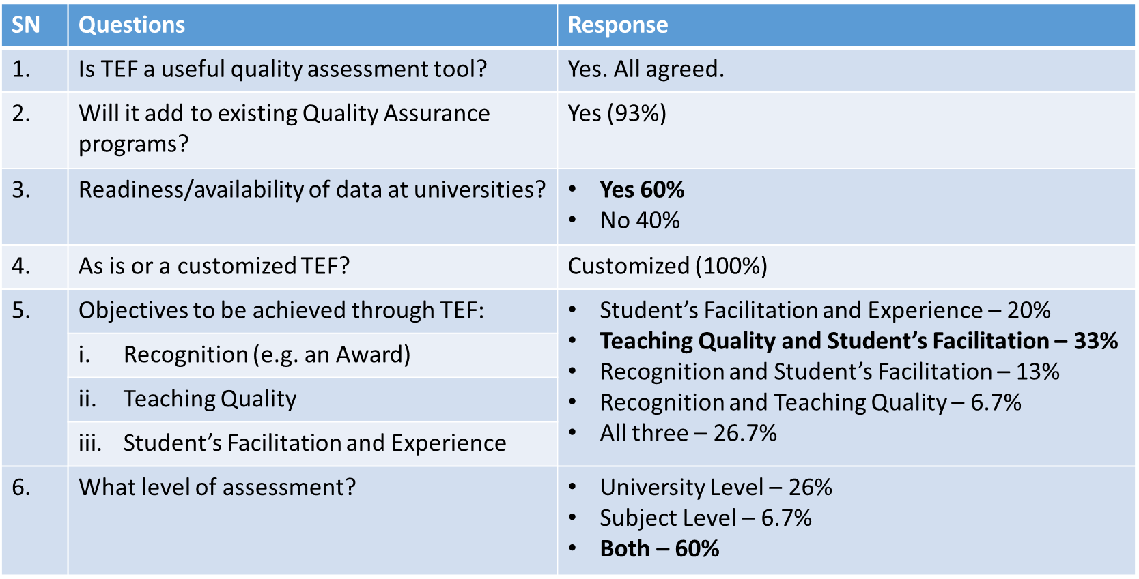
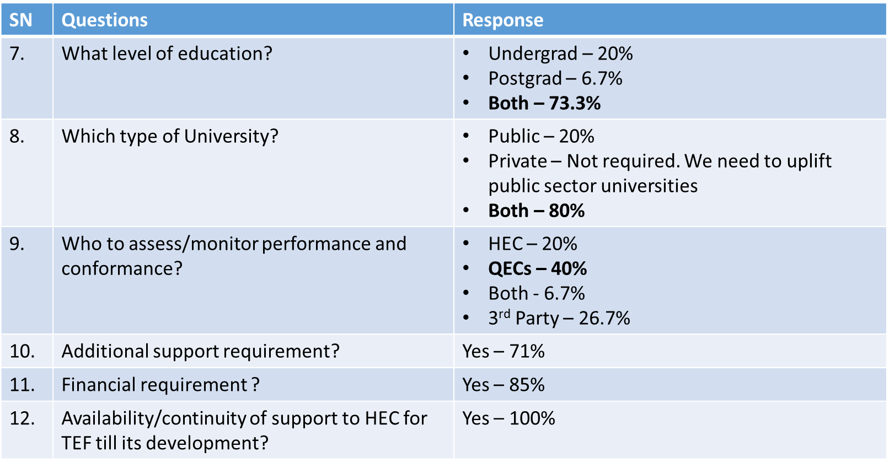

Appendix 5: Proposal on Capacity Building of Teachers on TEF (Visit to UK)
As per agreement between HEC & British Council, it has been proposed to build capacity of a group of Pakistani teachers, from amongst the already engaged faculty members, on UK’s TEF and the modalities associated with its implementation, monitoring and evaluation by arranging a visit. To achieve this, a short duration visit of the faculty has been planned to UK (universities & governing bodies) with below objectives:
Objectives of the visit: Develop thorough understanding of TEF as well as involvement/role of UK government in its adoption across the UK. TEF Chair in UK (VC – Sheffield Hallam University, UK) is expected to brief the participants.
- Develop understanding on the pre-execution study on readiness of the providers for TEF and its capacity building for implementation.
- Visits to at least two TEF Gold and one Silver rated UK universities (two from public and other from private provider) to get firsthand knowledge on how these universities adopted the framework.
- Develop understanding of the data (physical/digital) required to be maintained/arranged by the university for implementing and monitoring TEF.
- Share existing teaching practices and student learning facilities in Pakistani universities with the UK universities to identify the gaps that TEF can fill.
- Develop a comprehensive report on findings of the visit and propose way forward to be shared with universities in Pakistan.
- Develop gap analysis report in coordination with UK consultant.
- Create awareness/knowledge of UK’s TEF among universities in Pakistan before its development which will facilitate its implementation in later stages of the project.

Female teachers’ representation will be ensured in the selected group.
Officials from both HEC and British Council (3 HEC, 2 BC - tentative) will be part of the visiting group to provide leadership and support to the faculty.
Duration of Visit: A week to ten days duration visit is proposed to for meeting of Pakistani teachers with relevant stakeholders (TEF Chair, Universities, Governing bodies).
Visit Activities (Tentative): Overall objectives of the visit is to develop TEF by developing understanding of UK’s TEF and considering existing practices in Pakistani universities, thus the activities would be centred around meetings with university management/faculty and TEF management and governing bodies.

