reach 1 million by participating in “GREAT sTUDENT FILM”!

[Form] Ads on GREAT Student Film

Institution
Address
Website
Contact details |  | Name
 |  | Phone
 |  | Email
Interested in participating in ( Please tick the box below)
Option A |  |  | Option B |  |  | Option A + B
Logo

Please send your university logo separately to Sinae.Kang@britishcouncil.or.kr.

[Appendix] Examples of advertising platforms

1. British Council Blog
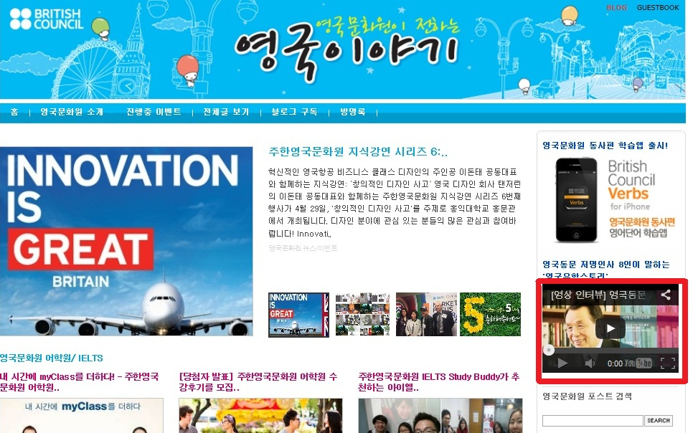

2. Education UK website (Korea) - ‘News and events’ section
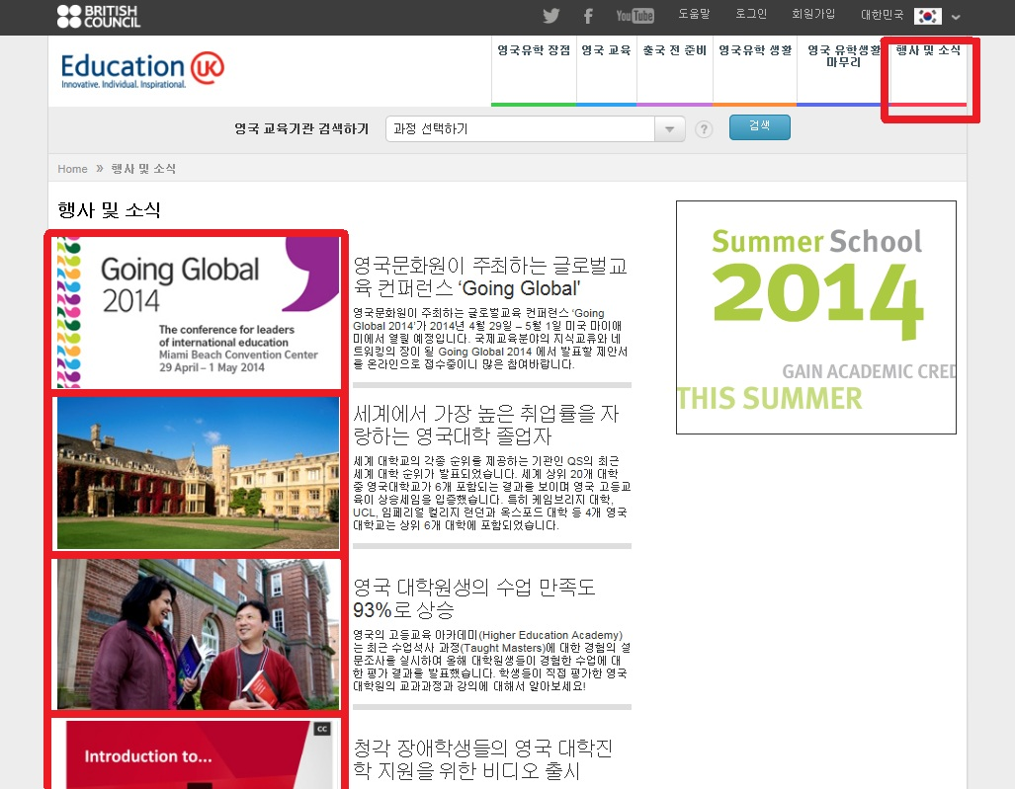
3. British Council Korea corporate website - ‘Study in UK’ section

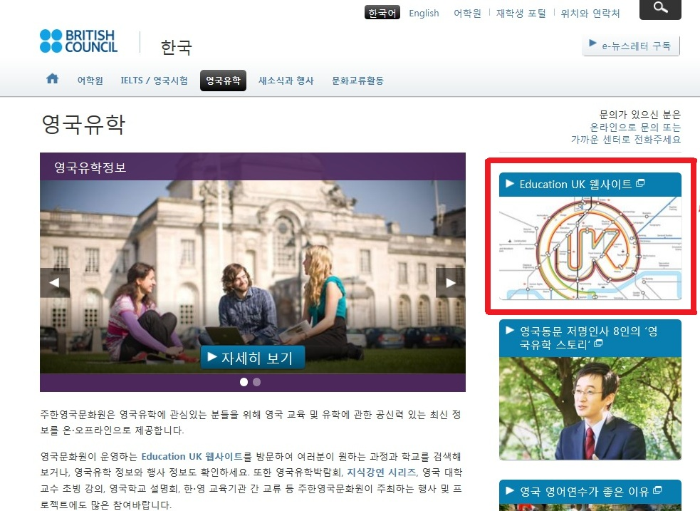

4. UK institution’s logo will be shown as a closing credit after British Council and Education UK logos
