Advertise your institutions on GREAT/EudcationUK comics!

British Council Korea launched GREAT webtoon (web-based cartoon composed of 12 episodes) on Naver on the 9th July and its first six episodes have already reached 1.7 million unique viewers with a rating of 9.9 out of 10. The rest of episodes are expected to receive a continued attention from the digital audience. Based upon this success, we will be producing a handbook which contains the 12 webtoon episodes and profile pages of 20 UK institutions. Only 20 institutions will get a chance to be included in the handbook considering the style of the publication.

12 episodes of the GREAT webtoon are created based upon themes including Knowledge, Creativity, Innovation, Entrepreneurship, Heritage, Fashion, Sport and Music. Any UK institutions who can best describe the mentioned themes would be a great fit for the handbook. It is confirmed from the viewers’ comments that the audience much appreciate the diverse study environment of the UK.

You can check out our cartoon on GREAT webtoon on Naver called “8.5, Distance between You and I”
Cuts from the first episode are shared below.
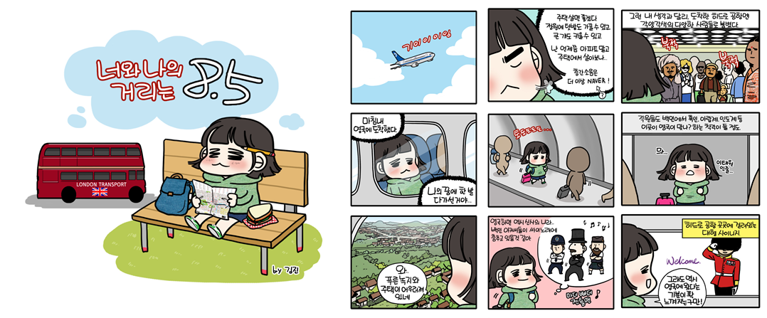

1,000 copies of this cartoon handbook will be launched at the forthcoming Education UK exhibition on 16-17 November, Seoul. A further batch of 1,500 copies will be circulated at both British Council and the partners’ premises.

We would like to invite interested UK institutions in this opportunity as follows:
- Target audience: from teen agers to early 40’s (students and parents)
- Number of copies: 2,500
- Promotion and distribution channels: two British Council offices, up to sixty bank partner branches including university campus branches, an airline partner’s branch, six selected UK special agencies (launch will be promoted through British Council e-newsletter and press release)
- Page layout and size: two pages of profile with a location map (size to be advised)
- Fee: £ 590 (translation fee included, VAT excluded)

Please send your interest with the completed profile form (attached) to Ms Jooyoung Moon, Project Officer Education & Society (Jooyoung.Moon@britishcouncil.or.kr) by Monday 23rd September. This is the first come and first served basis so could be closed before the deadline.

[Form] Institutional profile

Name of institution
Address | This will be marked on the map.
Website
SNS channels
Total student number
Total faculty number
Percentage of int’l students (%)
Employment rate (%)
Contact person
Contact phone number | e.g. + 44 (0) 1234 567 890
Contact email

Entry requirements for international students
*This is an example for HE institutions. Please feel free to make a change for schools and further education colleges
 | UG |  | PG |  |  | MBA (if applicable)
English proficiency (IELTS)
Tuition fees (£)  Please add a column where necessary (i.e. law, art/design) | Foundation | ELT |  | MBA | Humanities  Social Science |  | S&T  Engineering | Medical studies
 |  |  |  |  | UG |  | UG | UG
 |  |  |  |  | PG |  | PG | PG
Academic background | If applicable
Professional certificate | If applicable
Work experience | If applicable

Glance at the institution
Academic strengths | Max 200 words
Facilities offered to students | Max 200 words
Scholarships, bursaries, funding available for int’l students | Max 150 words (if applicable)
Living costs (£, year)

Career path and/or testimonials of alumni (any Koreans would be better received)
Max 200 words

Logo and two photos (high resolution, at least 1MB for printing purpose)

