ELES Area - Peru

Request for Expression of Interest (EoI)

The British Council
The British Council is the United Kingdom’s international organisation for cultural relations and educational opportunities. Its purpose is to build engagement and trust for the UK through the exchange of knowledge and ideas between people worldwide. It seeks to achieve its aims by working in education, science, governance, English and the arts.
The British Council was established in 1934 and incorporated by Royal Charter in 1940. It is registered as a charity in England and Wales (charity no. 209131) and Scotland (charity no. SCO37733). It is also an executive non-departmental public body, with the Foreign, Commonwealth and Development Office as its sponsoring department.
Its primary charitable objects are set out in the Charter and are stated to be to:
- Promote cultural relationships and the understanding of different cultures between people and peoples of the United Kingdom and other countries;
- Promote a wider knowledge of the United Kingdom;
- Develop a wider knowledge of the English language;
- Encourage cultural, scientific, technological and other educational co-operation between the United Kingdom and other countries; and
- Otherwise promote the advancement of education.
The British Council works in more than 100 countries around the world. It has its headquarters in the UK, with offices in London, Manchester, Belfast, Cardiff and Edinburgh. Further information can be viewed at www.britishcouncil.org.
The British Council in Peru
The British Council operated in Peru for 60 years before a temporary closure in early 2000s. The organisation re-established in Peru in 2014 as a branch of the British Council. Since its re-entry, the British Council in Peru has delivered activity in three main areas: English and Exams, Education, and Arts.
The present opportunity sits in the Education strand of our activity.
Opportunity context
The Ministry of Education (MoE) operates the Programme for the Improvement of Higher and Technical Education (PMESUT for its initials in Spanish). PMESUT is also adjoined to the Ministry and its role is to manage an MoE-IDB (Inter-American Development Bank) US$ 200M fund whose objective is improving quality both at HE and technical education levels. The loan will be managed until end of 2022. PMESUT regularly opens calls both for public universities and technical education institutes in Peru to apply to funding opportunities that allow them to improve the quality of education they offer. Subsequently, local and international suppliers are also invited to apply for calls to supply required services.
In 2020-21 we delivered our first project for PMESUT in which we provided technical assistance to six public universities so they could transfer key courses to online delivery, improve their online education delivery strategies and manage online education more robustly. The project delivered technical assistance and training, impacting close to 1,000 university professors, more than 1,700 university students and about 20 members of the university technical teams.
The opportunity
PMESUT has opened a call (Call 6) to Peruvian universities to support the revision and reformulation of pedagogical/academic improvement plans universities, so these plans are enhanced for future delivery. The plans could also aim to support their graduates to move smoothly into the world of work. These plans are expected to be implemented over a 9 to 10-month period.
The information contained in this document is based on the call terms for applicant HEIs that PMESUT published in their public website and on preliminary terms of reference. This information might change once final terms of reference are provided to potential service suppliers.
Plans must focus on one of two strands:
- Strand 1: Support for academic-pedagogical innovation (Choice of sub-sets suggested to universities include: Updating school study plans, student exit profile, updating foundation programmes study plans, design programme and strategies to address secondary school-leavers and offer pre-foundation programme, reviewing and strengthening professors’ monitoring-evaluation and PD pathways)
- Strand 2: Support for virtual education and academic innovation (Choice of sub-sets suggested to universities include: Designing and implementing online course delivery area (including monitoring-evaluation processes, technical assistance for optimal use of LMS), technical assistance for the creation of online programmes (including training for researching market, programme/course planning and academic-administrative management, support to increase Innovation strategies in academic-administrative areas in online learning to increase university International outlook)
University teams may apply with projects on either strand (any choice of sub-sets). They may choose to apply with two projects as well, but only the strongest one will be financed.
The British Council aims to support Peruvian Education and open opportunities for the UK sector by engaging in this process. British Council in Peru is established as a branch of the British Council in the UK, which allow us to lead on the project and partner with UK organisations for project delivery.
The opportunity for UK HEI’s will entail a 110-calendar day project to work with teams of university professors or managers (Spanish speaking) coming from a selection of 30 public universities to help them refine and implement the improvement plans they propose. In short, the project requires the strengthening of Peruvian universities’ capacity to develop improvement plan projects, enhancing quality education in accordance with national and regional standards.
Given our global expertise and our previous experience in Peru, we expect to focus primarily on Strand 2 (see “Opportunity Context” above).. However, if you are interested in working on strand 1 the EoI submission document (see “Express your Interest” section) gives room for potential partners to express their interest in either strand if they have specific track and team available.
The final outcome of this project is that each team leave the project with a strengthened design and development pathway for their academic and pedagogical improvement plans.
What we are looking for
We are looking for potential partner institutions, consortia or organisations that can contribute to the project at proposal design/submission and delivery stages (delivery subject to successful application outcome and contract-negotiation). Interested partner institutions or organisations (on either strand) should fit the following profile:
- UK HEI (including consortia), that delivers HE and that delivers education in academic/pedagogical management with documented experience in areas 2-7 below
- At least 10 years’ experience in academic-pedagogical management at HE level
- At least 2 projects implemented in the last 5 years (locally or internationally delivered) relevant to the strand you are interested in.
- At least 2 projects implemented in the last 5 years in which there was a transfer and application of T-L methodologies oriented towards academic-pedagogical management
- At least 3 projects implemented in the last 5 years in which academic-pedagogical plans were improved to benefit public or private universities (local or international).
- Experience in delivering virtual training programmes
- At least 3 projects implemented in the last 5 years which involved using Information-Communication Technology (ICT), digital resources and Learning Management systems (LMSs) at HE level
Additionally:
- The institution should have flexibility to adapt the programme to specific Peruvian university contexts and needs
- The institution will have the capacity to provide training and technical assistance, preferably in Spanish, both synchronously and asynchronously to the end beneficiaries
- The institution should be willing to comply with proposal design/submission demands (including scans, documents, proof of track, and signing a pre-bid agreement with the British Council) in a very short timeline – around 10 calendar days.
- The institution should be willing to hand over to PMESUT all training recordings and materials generated during training and technical assistance. PMESUT requires ownership of these materials.
- The institution should be able to supply the following staff:
A pool of trainers or staff to deliver technical assistance A pool of ICT Specialists with digital skills and verifiable experience in the task to support project teams in LMS management and digital resources for training and technical assistance.
Staff should be flexible (willing to adapt to changes / time difference), preferably proficient in Spanish (all skills) and able to provide copies of their education/experience documents for application purposes.
General activities to deliver
The activities to deliver during the 110-day-project include, but are not limited to:
- Coordinate proposal design and application requirements with British Council delivery coordination team (PeDCT)
- Participate in regular coordination meetings with standing and/or specific agenda items
- Design, manage and provide the overall training programme and technical assistance plan
- Provide training to university project teams focused on the subset of the strand they have chosen for their improvement plan (this might require contextualisation / bespoke adjustments)
- Train university teams and provide technical assistance for the improvement/reformulation of their project diagnostic, project monitoring and evaluation model, project plan and project budget
- Provide a virtual visit to a model institution specialised/focused on academic-pedagogical management
- Provide support to strengthen the criteria proposed by the Directorate of Higher Education Management (DIGESU) and PMESUT for the evaluation of the improved/reformulated projects
- Organise and participate in a closing event where the improved/reformulated plan is handed over to the university and their team.
- Actively contribute to the collection of data and writing of two progress reports and one final report according to project and customer demands, matrices and templates.
All activities to be delivered in Spanish language. If the institution cannot meet this requirement, we can look for alternatives to deliver the project.
Tentative project timeline
The circles in the following graph shows PMESUT timeline. The implications below the circles show how this timeline impacts internal processes with potential partners.
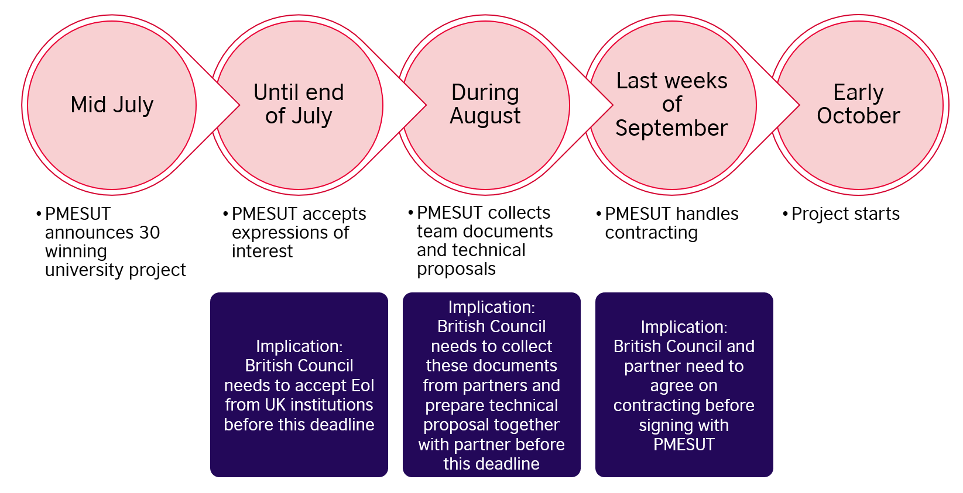
Tentative project budget
Final budgets are yet to be approved by PMESUT and overall level of funds available to us will be dependent on the number of Peruvian University partners we are successful in securing.
Initial calculations suggest that the level of funding available to UK institutions involved in implementation will be in the range of £6,000-£12,000 per Peruvian partner (considering 6 partners as a minimum workable number).
As conversations evolve with the potential UK partner(s) and we agree on percentages of participation in the project, we envisage a certain level of flexibility on these figures.
What’s next?
British Council will receive expressions of Interest from UK HEI’s until 19 July 2021 (6pm BST ). We will analyse all EoIs and will contact institution(s) that best fit(s) the requirements by 23 July, to submit an expression of interest to PMESUT by the deadline of end of July, as stated in the project timeline above.
Depending on the volume of expressions of interest received, may not be able to provide feedback to unsuccessful institutions until the week commencing 9 August.
The information contained in this document may change when final Terms of Reference are published by PMESUT, that is after the 30 beneficiary universities have been selected.
Contact
For comments, questions and/or to submit your EoI document, you may contact
Ralph Grayson
Education Services Manager Peru
British Council
ralph.grayson@britishcouncil.org
We will reply to all questions received until 12 July (12 pm Peru time) in one single Q&A sent by 14 July.
Show your interest
If your institution meets all / part of the profile set out above and you’re keen to partner with the British Council, send us your EoI. You can use the following response sheet to let us know your details and how you meet the profile.

Expression of Interest response
Institution/Organisation details
Full name of the institution / organisation
Registered company address (RUC in Peru) - if applicable (e.g. UK institutions with legal representation in Peru)
Legal Representative - if applicable
Registry number (“Registros Publicos” in Peru) - if applicable
Main contact details (name, e-mail address, mobile phone number if WhatsApp messaging is used)

Strand
This expression of interest refers to Strand 1 – Strand 2 (delete as applicable)
If you are interested in both strands, use one Expression of Interest response per strand.
State your interest
Briefly explain why you are interested in this project or strand (80-11 words)

Briefly outline your track record:
Summarize key information of your institution’s 10 years’ experience in academic-pedagogical management at HE level
Relevant experience | Years (from – to) | Key work delivered (max 50 words) | Additional details (if applicable)

Please detail at least 2 projects implemented in the last 5 years (local or international). Focus on the strand selected.
Name of project | Year of implementation | Key work delivered (max 50 words) | Budget and funder

Please detail at least 2 projects implemented in the last 5 years in which there was a transfer and application of T-L methodologies oriented towards academic-pedagogical management.

Name of project | Year of implementation | Summary of work delivered (max 100 words) | Budget and funder

Please detail at least 3 projects implemented in the last 5 years in which academic-pedagogical plans were improved to benefit public or private universities (local or international).
Name of project | Year of implementation | Summary of work delivered (max 100 words) | Budget and funder

Please detail your institution’s experience in delivering virtual training programmes (two or three key projects)
Name of project | Year of implementation | Summary of work delivered (max 100 words) | Budget and funder

Please detail at least 3 projects implemented in the last 5 years which involved using CTI, digital resources and LMSs at HE level.
Name of project | Year of implementation | Summary of work delivered (max 100 words) | Budget and funder

Your staff and project team
Please give us an outline of the team you envisage would work on this project and how they could meet the criteria set out in points 8-12 above and activities listed (max. 80 words per criteria)
Criteria 8 (Flexibility)
Criteria 9 (Capacity to deliver synch and asynch content, preferably in Spanish)
Criteria 10 (Capacity to comply)
Criteria 11 (Hand over to PMESUT all training recordings and materials)
Criteria 12a (Availability of staff)
Criteria 12b (Staff documentation)

Is the tentative budget in line with your expectations at this stage (to the best of your knowledge)?
☐ Yes
☐ No
Additional information (tick as appropriate)
We are also interested and can partner for the other Strand.
(If you tick this box, briefly explain to what extent your institution can deliver project activities to university teams that have chosen this strand)

Declaration
I understand with this form I express an interest in the opportunity and I wish to be contacted by the British Council for further pursuit development. I understand this is not a contract or a way to enter into contractual terms with the British Council. I understand this form and contents will remain in confidentiality by the British Council and will only be treated internally for pursuit purposes.
Please tick:
I agree

Signed
Name
Date

