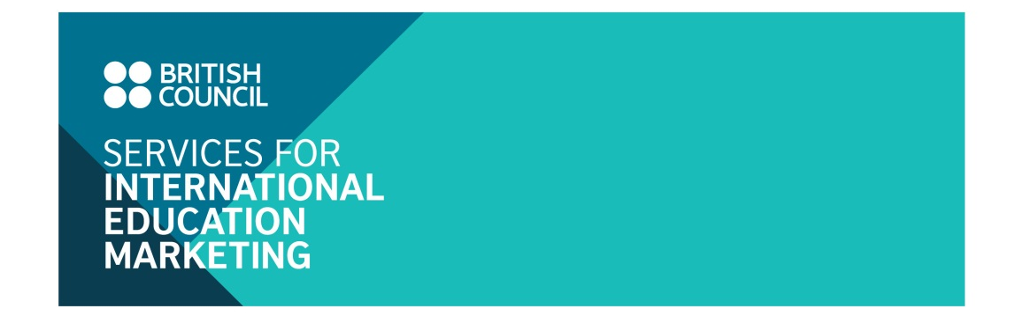
Study UK Guide 2018
Application form

I. UK INSTITUTION DETAILS
Name of institution:
Name of contact person:
Contact address:
Tel:
Email:

II. PACKAGE OPTIONS AND COSTS
Please indicate your selected advertising option(s) by ticking the relevant box(es):

Package option(s) | Size | Cost
6 months package - Distribution from March to August 2018
1. Inside page (6 months)  ☐ Full page | Full page  W: 21cm x L: 29.5cm | £700
☐ Half page | Half page  W: 21cm x L: 14.5cm | £400
12 months package - Distribution from September 2018 to August 2019

1. Inside front cover OR inside back cover (12 months)  ☐ Full page | Full page  18.5cmW x 25.0cmH | GBP1,500
2. Inside page (12 months)  ☐ Full page  ☐ Half page | Full page  18.5cmW x 25.0cmH | GBP1,000
 | Half page  18.5cmW x 12.5cmH | GBP600
Added value service: Participating institutions who sign up for the above advertising packages will be offered opportunity to promote your student/alumni/staff profile on the Facebook ‘UK in my eyes’ (>87,000 followers) as follows:
- With Full page option: 02 facebook posts free of charge on the Facebook ‘UK in my eyes’
- With Half page option: 01 facebook post free of charge on the Facebook ‘UK in my eyes’
Notes: - All of the costs above are exclusive of 20% UK VAT;
- A discount of 5% will be offered to institutions that advertised in the previous 2017 edition of the guidebook

III. TOTAL COSTS

Subtotal of selected options
Value added tax
TOTAL

IV. UK INSTITUTION DECLARATION
I confirm that the above named institution wants to be included in the above selected advertising option(s) with the total cost indicated in section III above.
I understand that if this application is accepted, the terms and conditions detailed in the next page will form an agreement between us and the British Council Vietnam.
I would like the ready-for-print advert: ☐ to be kept originally in English
☐ to be translated into Vietnamese

Typing your name will be taken as being as your signature.

Your name |  | Date

The completed application form should be sent electronically to:

Linh Trinh, Education Marketing Assistant
Email: Linh.trinh@britishcouncil.org.vn

V. TERMS AND CONDITIONS

Acceptance
The British Council Vietnam reserves the right to accept participating institutions in the relevant advertising options on a first come first served basis until we reach sufficient number of participants for each publication.

Applicants will be notified by email of the acceptance within one week as of date of application.

Payment schedule
The British Council Vietnam will invoice the participating institution for the cost applicable to the advertising option(s) selected in the previous page.

The term of payment is 30 days of the invoice date. In accordance with British Council audit procedures reminder letters will be issued for all outstanding invoices over 45 days. Until all invoices are cleared, a block will be placed on your British Council account. Further applications to participate in British Council events and other organised programmes of activity cannot be accepted until all outstanding invoices have been paid.

Cancellation
Cancellation fees will be charged for withdrawal from the publication, as of the date of receiving Notice of Withdrawal via email:

- At 50 per cent of the full fee of the selected package(s) for withdrawals received between 10 and 25 February 2018.
- At 100 per cent of the full fee of the selection package(s) for withdrawals received on or after 26 February 2018.

