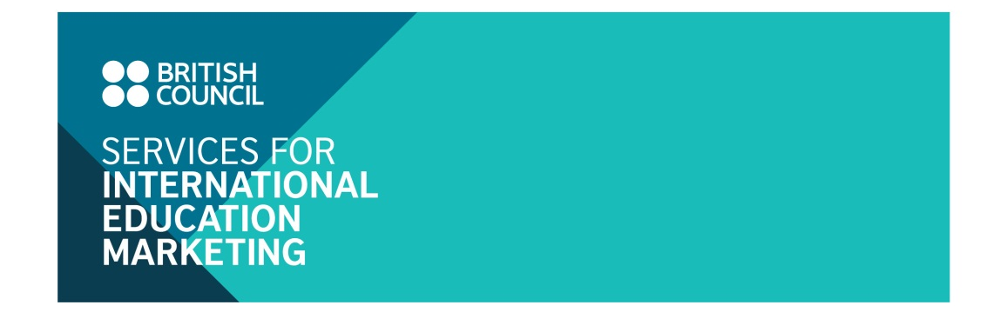

Advertising Opportunities

“UK in My Eyes” Programme in 2016

www.ukinmyeyes.vn

- The programme ‘UK in my eyes’ was developed by the British Council Vietnam with an aim to connect alumni and those who are studying in the UK with Vietnamese prospective students to help them learn more about studying and living in the UK.
- Under the UK Alumni Strategy of the British Council, the programme ‘UK in my eyes’ has served effectively to strengthen key Education UK brand messages through student testimonials who act as ambassadors to promote UK culture and education. The programme, at the same time, will be a good platform for UK institutions to promote their UK alumni strategy and institutional profiles.
- The “UK in my eyes” programme has 2 main components:
- The ‘UK in my eyes’ website at http://www.ukinmyeyes.vn/ (70,000 unique visitors/year) is currenly featuring over 350 stories of UK alumni who participated in the programme since 2010. This site helps Vietnamese prospective students easily find experiences shared by alumni from UK institutions that they are interested in. The website is categorised with following topics:
Studying in the UK: Schools, subjects, tips for learning, application procedure and scholarship
Living in the UK: Accommodation, living expenses, employment, shopping, travel
My institution: Profiles of UK institutions and colleges with their Vietnamese alumni’s testimonials
Events: Education UK events organised by British Council
Q & A: selected questions and answers about studying and living in the UK
- The ‘UK in my eyes’ Facebook page - https://www.facebook.com/NuocAnhTrongMatToi (77,000 members) is a social media platform to connect prospective students with alumni through frequent updates, activities, and campaigns during the year. It’s also an effective communication channel to help UK institutions approaching Vietnamese prospective students through online Q & A sessions on wide range of topics about studying and living in the UK.
- In 2015, the British Council Vietnam successfully organised the 4th annual ‘UK in my eyes’ competition in collaboration with VNExpress – one of leading online newspapers in Vietnam. With nearly 200 entries from Vietnamese students in the UK and alumni and 350,000 page views to the competition website, the event was a successful campaign to promote the programme to the wider Vietnamese public.
- In 2014-15: 10 UK institutions placed a 12-months promotion package in the ‘UK in my eyes’ programme. These institutions have benefited from the participation of their students and alumni in the programme, who acted as ambassadors to promote their institutions through their inspiring stories. 45 alumni stories from participating institutions were posted on the website. 4 online Q & A sessions were organised which helped institutions reach 150 direct enquiries from participants.

- Call for UK institutions to participate in this programme:
We recommend this programme to UK institutions who aim to have a solid profile development marketing strategy in Vietnam. These institutions can take advantage of this programme to use their alumni as institutional ambassadors to develop institutional profile in Vietnam.
Detailed benefits for UK advertising institutions include:
- Participation in one of Facebook Q & A sessions on the Facebook page ‘UK in my eyes’ http://www.facebook.com/NuocAnhTrongMatToi. Facebook Q & A session to promote UK institutions, their courses on offer and student life in the UK was a new initiative of the programme in year 2016 with:
• 8 sessions from Jan. to Dec. 2016, 2 hours/session.
• Up to 4 UK institutions could participate in one session
• Topic: Different aspects of studying and living and courses offered at participating UK institutions
• Each session is promoted widely via Facebook sponsored posts and on all British Council communication channels
Facebook Q & A sessions schedule in 2016/17
Week | Jan 16 | Feb 16 | Mar 16 | Apr 16 | May  16 | Jun  16 | Jul  16 | Aug  16 | Sep  16 | Oct  16 | Nov  16 | Dec  16 | Jan  17
Week 1 |  |  | Pathway Exhibition |  |  |  | Education UK talk – Pre-departure | 1-6 Aug |  | Education UK Exhibition |  | Christmas | 3-7 Jan
Week 2 |  |  | Pathway Exhibition | 4-9 Apr | 9-14 May |  | Education UK talk – Pre-departure |  | 5-10 Sep | Education UK Exhibition |  | Christmas
Week 3 |  | 24-Feb | Pathway Exhibition |  |  | 13-18 June | Education UK talk – Pre-departure |  |  | Education UK Exhibition | 14 - 18 Nov | Christmas
Week 4 |  |  | Pathway Exhibition |  |  |  | Education UK talk – Pre-departure |  |  | Education UK Exhibition |  | Christmas
Week 5 |  |  | Pathway Exhibition |  |  |  | Education UK talk – Pre-departure |  |  | Education UK Exhibition |  | Christmas

- Placing a web-banner that links directly to the institutional websites on the homepage of the Programme site at http://ukinmyeyes.vn. Flexibility is given for UK advertising institutions to change the web banners design and URLs of the links throughout the year, allowing institutions to utilise this advertising channel for different marketing purposes in Vietnam.
- An institutional landing page on the Programme website in Vietnamese, featuring stories of alumni and promoting alumni events, scholarships and institutional information that are relevant to Vietnamese prospective students. FREE design, translation, edit and management fee of this landing page from the British Council. However, the British Council reserves the right to edit the content to ensure appropriate tone of voice.
- Institutional profile and alumni stories that are relevant with Vietnamese prospective students are promoted on all British Council communication channels:
• Education UK website (4,500 unique visitors/month)
• British Council website (90,000 unique visitors/month)
• Education UK Monthly E-newsletter (send to 13,000 email database of prospective students)

- Advertising Package
Advertising Benefits | Package 1  GBP 2,000 | Package 2  GBP 1,200 | Package 3  GBP 500
- Participating in 01 Facebook Q & A session about studying in the UK in the ‘UK in my eyes’ Facebook page | v | v | v
- One advertising web banner on homepage of the Programme website | 12 months  v | 6 months  v
- One landing page (in Vietnamese) on the Programme website, featuring institution profiles / alumni stories and other institutional news | 12 months  v | 6 months  v
- Institutional profiles and alumni stories are promoted in British Council communication channels (Education UK website; British Council website; Education UK monthly E-newsletter) | 12 months v | 6 months v | In communication campaign for Facebook Q&A session  v
Additional benefits:  • Flexibility to change the design and URL of the web banner at  any time  • FREE design, translation, edit and management of the landing  page by the British Council | v | v
Note: the above rates are exclusive of 20% UK VAT

- Registration
Deadline for UK institutions who are interested in participating in Facebook Q&A sessions from Feb to Jun 2016 is 5 Feb. 2016. Please send your expression of interest to:
Tuong Truong
Education Marketing Officer
E tuong.truong@britishcouncil.org.vn

