Going Global Partnerships, Gender Equality

Gender and Inclusion Guidance Note  
  
September 2022

Introduction

The gender and inclusion note lays out the legal and policy context for Overseas Development Assistance (ODA) funded projects and key definitions relating to gender and inclusion used by the British Council. The note also outlines a range of gender and inclusion issues that applicants are expected to consider when developing their proposal. These are indicative: the thematic focus and methodology will further determine and refine the gender and inclusion issues to be addressed through the partnership project.

ODA funding: the legal and policy context

The legal and policy context for ODA funding is framed by three UK acts. **First, the International Development Act (2002)** with an explicit requirement that the provision of ODA can show it is likely to contribute to poverty reduction[1]. Second**,** the **International Development (Gender Equality) Act (2014) which requires ODA spending ‘to contribute to reducing inequality between persons of different gender’**[2]. Third**, the 2010 Equality Act requiring public organisations[3] to promote equal opportunities for everyone** and **protect the rights of those with protected characteristics** (including but not limited to gender, sexual orientation, age, race and disability) through implementing policies and strategies which prevent disadvantage and discrimination. These legal accountabilities set the parameters for ODA funded projects supported by the British Council and to ensure that funding shows development impacts that are poverty focused, gender-sensitive and socially inclusive.

Key Definitions

For the purposes of the Going Global Gender Equality Partnerships, the British Council uses the definitions for sex and gender adopted by UK government to aid assessment of the UK’s progression towards achievement of the UN SDGs[4].

The UK government defines **sex** as:

referring to the biological aspects of an individual as determined by their anatomy, which is produced by their chromosomes, hormones and their interactions

* generally male or female
* something that is assigned at birth

**Gender** is defined as:

* a social construction relating to behaviours and attributes based on labels of masculinity and femininity; gender identity is a personal, internal perception of oneself and so the gender category someone identifies with may not match the sex they were assigned at birth
* where an individual may see themselves as a man, a woman, as having no gender, or as having a nonbinary gender – where people identify as somewhere on a spectrum between man and woman

These gendered constructs, and to some extent identities, vary across organisations, countries, legislative and cultural boundaries. Gendered attitudes and behaviours are (re) produced at multiple levels – in individuals’ identities, and expectations, in social, economic and political institutions, and in wider society and culture. This leads to inequalities between genders, where one gender, usually women, are excluded or disadvantaged in terms of accessing and benefiting equally from economic, political and societal resources and opportunities[5]. SDG 5 which aims to achieve gender equality is both a goal in itself and a target for all SDGs recognising that the discrimination and disadvantages faced by women and girls overlaps and intersects with other forms of discrimination.

The concept of ‘**Intersectionality**’ is an important component in understanding gender equality. it incorporates the idea that gender, social inclusion and poverty can combine to further exclude gender identities. It is broadly defined as

‘the interconnected nature of social categorisations such as race, class, and gender, regarded as creating overlapping and interdependent systems of discrimination or disadvantage or a theoretical approach based on such a premise[6].

The concept speaks to the core principle of the SDGs – to leave no one behind. To meet this, eight characteristics have been identified by the UN[7] – **level of income, sex, age, race, ethnicity, migration status, disability and geographic location** – as important to ensuring everyone benefits from actions to reduce inequalities and poverty. There is recognition too that there may be other characteristics relevant in national contexts such as religious belief.

For more information on intersectionality see:

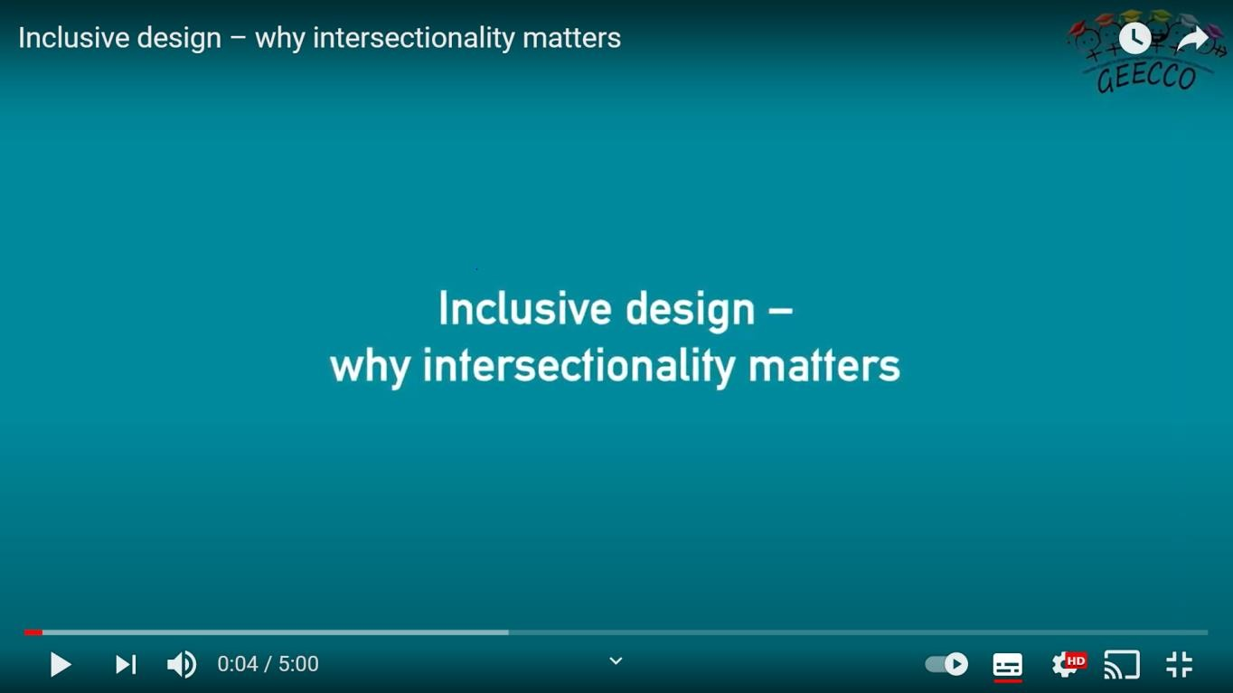

Use Cntrl+Click on picture to play video or copy the following link into your browser <https://youtu.be/U4eRb1NM21A> (connects to external website), Source: TU Wien

Gender sensitive and transformative projects consider and assess how particular intersections of identities and social positions impact on access to rights and opportunities, and how policies, programmes, services and laws affect people in different, context-specific or even unexpected ways. Understanding different intersecting systems of discrimination and disadvantage enables a better understanding of the different experiences of different groups of women, (and men), and how gender inequality is shaped by these intersections[8].

From this conceptual framing, **social Inclusion** -defined as the process of improving the terms of participation in society, particularly for people who are disadvantaged, through enhancing opportunities, access to resources, voice and respect for rights[9] - is an integral part of addressing gender (in)equalities. Much of the research and debate focuses on the three domains of social participation, economic participation and political participation as key aspects of social inclusion, thereby capturing #elements around gender equality and poverty[10]. This is a useful analytical tool for developing gender

sensitive and socially inclusive methodologies. They should not be seen as prescriptive. Applicants are encouraged to develop their own approach to addressing social inclusion within the proposed approach and methodologies.

Gender and Social Inclusion Issues to Consider

Applicants to the Going Global Gender Partnerships are expected to show ODA compliance through tackling instances of under-representation, differential needs, and systemic disadvantage to support inclusion, to reduce the impact of bias and ultimately, to contribute to reducing poverty and inequalities between genders. In line with British council values and policy commitments, consideration should also be given to the equality, diversity and inclusion aspects of the project, particularly inclusivity issues for disabled persons[11] and, in relation to race and ethnicity[12].

The British Council is seeking to fund projects that go beyond ODA compliance and have the potential to contribute to reducing gender inequalities in the higher education sector. Applicants should therefore clearly demonstrate how their proposed project is **gender transformative.**

By **“gender transformative”** we mean that gender inequalities are analysed and integrated into the project’s rationale, design, and methodology. There is an explicit intention to challenge the root causes of gender discrimination, for example, through addressing discriminatory gender norms, stereotypes and unequal power relationships between the sexes. Activities and methodologies focus on strategic needs that improve women’s and girls’ sub‑ordinate position in society[13].

Applicants are also encouraged to consider the social inclusion dimensions of the project. Annex 1: lays out the criteria for the gender and social inclusion screening of submitted applications. Expectations for gender responsive and gender transformative programmes are provided.

The applicants will need to demonstrate this throughout the whole application and through the **Gender Equality Statement** (GES).

Applicants must outline how they have taken *meaningful* yet *proportionate* consideration as to how their proposed project will contribute to reducing gender inequalities, as required under the International Development (Gender Equality) Act 2014.Proportionate and meaningful means that applicants should think of gender and potential gender

issues in a way which corresponds in *size, scale* and *impact* of their project. Their answers should have meaning and be serious, important and/or worthwhile.

**Please note that the Going Global Gender Equality Partnerships is targeted to address gender equality issues – this is expected to be fundamental to the project design and delivery and should aim to be gender transformative (See Annex 1)**

The GES should be about the project specifically – the outputs and outcomes, the make- up of the project team, participants, stakeholders and beneficiaries of the project, and the processes followed throughout the project.

Applicants will have to address each criterion explained in the next slide individually on the application form.

The British Council reserves the right to reject a proposal where the GES has not been sufficiently considered.

The table below provides indicative guidance of the range of issues applicants should consider in developing their approach and methodology.

|  |  |
| --- | --- |
| **Project components** | **Issues to consider** |
| Project focus | * What exactly is the focus of the project and does this address a clear gender equality issue? |
| Analysis and rationale | * Has relevant research and analysis around gender inequalities in higher education relevant to the project been reviewed? * Has this been built into the rationale for the project. |
| Project methodology | * How will a gender focus be integrated into the approach? * How has the methodology addressed intersectionality and social difference, e.g., in the selection of target audiences, themes etc? * Does the proposed data disaggregation capture the range of social difference between women and girls, men and boys? |
| Potential Impact | * What are the gendered impacts? * If changes in policy and practice are potential impacts what differences are expected for difference groups of girls, e.g. low-income, ethnicity, migration status etc.? * Are there particular groups who are likely benefit more than others? |
| Roles | * Is there a gender specialist on the team? If not how will the project draw in gender expertise? * Are there any barriers to team members, particularly women a) being recruited b) carrying out their roles? If so, what measures have been taken to address these barriers? |
| Project context | * Are there links or synergies with existing projects or interventions addressing gender inequalities that would enhance the long-term impact? |
| Communication | * Are there ways or formats which could support the communication of the project outcomes to be inclusive and reach out to a) relevant decision-makers, b) women or c) other groups? |

For more question prompts see Annex 2.

Tips for writing your gender equality statement

**Start writing your statement early.**

**Analyse the gender implication of your project. For example:**

* Do you know about the gender issues in your field?
* Are you aware of the roles and responsibilities of people of different genders especially in the target country?
* What are the short and long-term implications of your work?
* Have you considered the views of different stakeholders in the target country?
* Will your outputs be accessible to people of different genders? If so, how?
* What are the roles of people in the project team? How will people be involved?

**Don’t forget to consider aspects of intersectionality in the context of your project**

**If you are unsure, you may wish to speak to your Institution’s EDI team or Research Office for** support

Common pitfalls

Statement is incomplete: not all questions have been addressed in a meaningful yet proportionate way. If a question is not applicable, applicants must explain why. An application will be ineligible if no justification is provided.

Too general: comments about EDI and/ or gender in general. Not providing specific information about the project. Text copied from the Institution’s policy is not sufficient. If applicants state the policy, we would expect details on how it will be implemented as part of the project.

Not considering the short and long-term impact that the project could have on gender.

Insufficient answers such as N/A or yes/no

Annex 1: Criteria for Gender and social inclusion screening of Going Global Gender Partnerships Applications

|  |  |  |
| --- | --- | --- |
|  | Gender | Social Inclusion |
| Gender/social inclusion unaware (or gender blind)  N.B. Although the term ‘gender blind’ is still used by some organisations, the British Council prefers the term ‘gender unaware’ | Programmes or projects do not recognise women’s rights and gender equality issues.  The specific issues affecting women are not identified at project design stage. They may only refer to issues affecting ‘people,’ ‘communities,’ ‘researchers’, ‘students’ ‘youth,’ ‘audiences’, etc. rather than breaking these groups down by sex. There is no gender analysis of the wider context and it is not clear how women, girls, men and boys are differently affected by a particular issue.  Gender equality is not addressed in the rationale and methodology, team composition, implementation plan, monitoring and evaluation and communications and influencing. | Social inclusion is not considered in the   * Analysis of the problem * Rationale and methodology * Team composition * Implementation plan * Communications and influencing |
| Gender/Social inclusion Neutral | Programmes or projects recognise gender equality issues in the analysis, but not in the response.  The differential needs of women and men are identified in the project documents but these are not being addressed in the project activities. | Social Inclusion is considered in the project’s analysis or rationale, **but** not in the response ie in the design and methodology or implementation  No or limited attention to team composition |
| Gender/social inclusion Sensitive | Programmes or projects address practical gender equality issues, but do not tackle the root causes of gender inequality.  A robust gender analysis has been undertaken to understand the different barriers and opportunities facing women, girls, men and boys using sex disaggregated data. There will be an analysis of the underlying causes of poverty and gender discrimination and the abuse of rights that are at play. Specific solutions to address the needs and concerns of women and girls are included in the project activities and outcomes. Activities are more likely to focus on women’s practical needs to improve their daily condition. | Social Inclusion is considered in the project analysis, rationale, design and methodology.  Data is disaggregated by some aspects of social inclusion e.g., age  Social inclusion/diversity is considered in team composition & reviewers.  Social inclusion-sensitive **does not** extend to action to address discrimination, exclusion and inequalities. |
| Gender/Social Inclusion Transformative | Programmes or projects improve both practical and strategic gender issues.  There is an explicit intention to challenge the root causes of gender discrimination, for example, through addressing discriminatory gender norms, stereotypes and unequal power relationships between the sexes. Activities and methodologies focus on strategic needs that improve women’s and girls’ sub‑ordinate position in society. This is an overtly political process. | Attention to diversity and social inclusions is integrated throughout the project including:  specific analyses of inequalities which is used to inform long-term practical changes in structural power relations and norms, roles and inequalities in relation to different aspects of exclusion and discrimination such as disability and racism.  team composition, partnerships monitored for diversity/social inclusion especially for disability and race  Outputs, results, communications and dissemination strategies are focused on contributing to increasing levels of social inclusion and sustaining the change through action |

**NB: Applications for the Gender Equality Partnerships will need to demonstrate that they are Gender transformative and at least social inclusion sensitive.**

Annex 2: Gender equality questions to consider in research

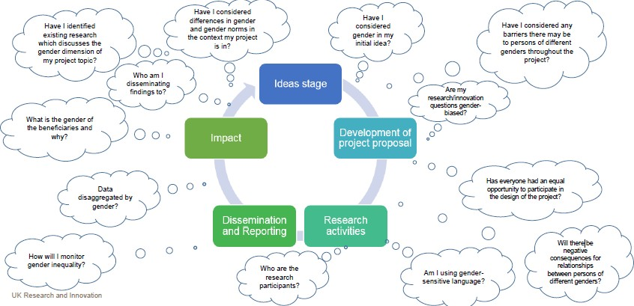

Source: UK Research and Innovation: <https://www.ukri.org/wp-content/uploads/2021/02/UKRI-250221-Gender-equality-and-international-development-research-and-innovation.pdf>

1. UK Parliament International Development Act .......“may provide any person or body with development assistance if he [*sic*] is satisfied that the provision of the assistance is likely to contribute to a reduction in poverty”. Available [here](http://www.legislation.gov.uk/ukpga/2002/1/contents).
2. UK Parliament International Development (Gender Equality) Act (2014). Available [here](http://www.legislation.gov.uk/ukpga/2014/9/section/1/enacted.).
3. UK Parliament Equalities Act (2010). Available [here](https://www.legislation.gov.uk/ukpga/2010/15/contents). There are nine protected characteristics: age, disability, gender reassignment, race, religion or belief, sex, sexual orientation, marriage and civil partnership and pregnancy and maternity. All of which were covered by protected by previously existing legislation which the 2010 Act replaced.
4. # UK Office of National Statistics (2019) What is the difference between sex and gender? Exploring the difference between sex and gender, looking at concepts that are important to the Sustainable Development Goals. Full report available [here](https://www.ons.gov.uk/economy/environmentalaccounts/articles/whatisthedifferencebetweensexandgender/2019-02-21).

  
5. March, C.: Smith, I. and M. Mukhopadhyay, (1999) A guide to gender-analysis frameworks, UK, Oxfam
6. Oxford English Dictionary, 2015
7. Paragraph 74.g of [Transforming our World: the 2030 Agenda for Sustainable Development](https://sustainabledevelopment.un.org/post2015/transformingourworld)
8. GDN (2017) Intersectionality. Reflections from the Gender and Development Network. Think Pieces November 2017. Available [here](https://static1.squarespace.com/static/536c4ee8e4b0b60bc6ca7c74/t/5a130e9d53450a0abd9c0f8f/1511198367912/Intersectionality+GADN+thinkpiece+November+2017.pdf).
9. UN Department of Economic and Social Affairs (2016) Report on the world social situation 2016. Leaving no one behind: the imperative of inclusive development. Available [here](https://www.un.org/esa/socdev/rwss/2016/chapter1.pdf).
10. Beall, J., & Piron, L. H. (2005). DFID social exclusion review. London: Overseas Development Institute, 32, 37.
11. British Council (2018) Promoting Inclusion A British Council guide to disability equality Available [here](https://www.britishcouncil.org/sites/default/files/guide-disability-equality.pdf).
12. British Council (2021) Race Equality through anti-racism guide. Available [here](https://www.britishcouncil.org/sites/default/files/race_equality_through_anti-racism_guide.pdf).
13. See British Council (2018) [Guide to addressing gender equality](https://www.britishcouncil.org/sites/default/files/gender_guide_external_july_2019.pdf), p18