Opportunity for UK ELT providers:
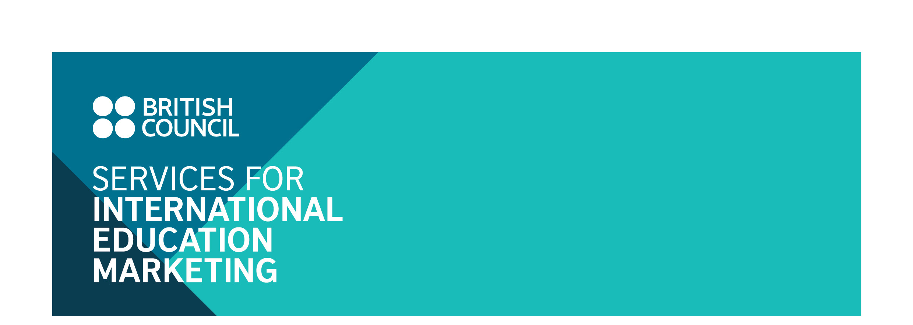
Promote your schools through the British Council “English Language Study Guidebook 2018/2019” to be published in Japan

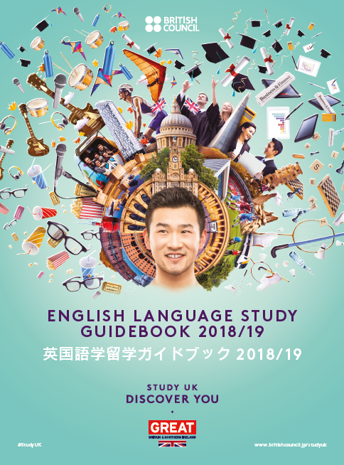
The British Council in Japan will publish a new edition of our English Language Study Guidebook in March 2018 and we are offering up to 25 UK English language schools and centres advertising space within the guide. The guidebook will be widely distributed at British Council Japan student-facing events from March 2018 to March 2019 including two Study UK Exhibitions. A 10% discount will be offered to those schools that participated in the 2017 edition.

This guidebook aims to help UK English language schools capitalize on the consistent recent growth in demand for English language study (see below for details)

What are the benefits for participating schools?

- Reach a large number of highly-motivated prospective students:
In addition to our two study UK Exhibitions, the British Council Japan participates in around 20 major annual study abroad events organized by leading universities and public bodies. Participants of these events are particularly keen to improve their English language ability and we will recommend the guide to them during face-to-face counselling.
- A cost-effective method of reaching a wide audience through multiple channels:
Hard and soft copies of the guide will be marketed widely through the British Council’s promotional channels making this a cost-effective way of raising awareness and maximising the exposure of your school without having to travel to Japan.
- Good quality localization is included in the package:
Your school profile will be quality checked by British Council staff, who have a deep understanding of the needs of the Japanese market, to ensure that your strengths are highlighted in the right context.

Market Background

1. According to a report published by Yano Research Institute Ltd., the market in Japan for English language business grew by 2.7% in 2016. The market is expected to continue to expand to 5.8 billion GBP (2.2% growth compared to 2016). The report points out that the opportunities for Japanese companies to use English for internal meetings and promotion are on the rise. It also suggests that the number of senior citizens interested in studying English abroad has been increasing.

2. Revision of the elementary school curriculum to double the English lesson hours for 10-12 year olds and the introduction of “foreign language activities” for 8-10 year olds. https://siem.britishcouncil.org/news/market-news/japanese-government-announces-change-english-language-education-primary-school

3. Four skills English tests will be introduced for unified entrance examinations for Japanese universities from 2020
https://siem.britishcouncil.org/news/market-news/four-skills-english-tests-be-introduced-unified-entrance-examinations-japanese

About the Guidebook
The guidebook will consist of contents prepared by the British Council highlighting the strengths of English language teaching in the UK along with information on participating schools. The printed version of the guidebook will be distributed widely to Japanese students and schools, while the on-line version will be downloadable through the British Council Japan’s main website for promoting study opportunities in the UK and various other channels.

- Dimensions: W169 mm×D229 mm
- Language: Japanese
- Total pages: approximately 44, full colour
- Print run: 2,000 copies
- Shelf life: 1 year (from March 2018 to March 2019)

- Contents of the guidebook
  - Strengths and attractions of English language study in the UK
  - [Featured article] Young learners’ courses
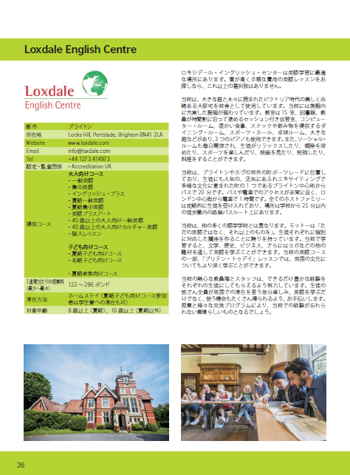
  - [Featured article] English Plus
  - A map of the UK to show the location of the schools (prepared by the British Council)
  - UK course information (profile of each school)

- Each profile page will consist of:
- General information (school name, logo, contact details, Information about accreditation, course provision / tuition fees, Accommodation options, Age range and Disabled access provision). The British Council will provide a template for schools to complete.
- Brief information about the school (up to 350 words)
- Up to three photographs of the school (the British Council, Japan will select 1-3 photographs that best fit the space)

Target audience
- General adults
- Japanese prospective students of UK English language schools and centres
- Academic / non-academic staff at elementary schools, junior high schools, high schools and universities
- Study abroad agents
- Parents

Distribution
Printed version (2,000 copies)
The guidebook will be distributed through the following channels:
- British Council events including two Study UK Exhibitions (March and October, 2018)
- In-house study abroad seminars focusing on English language study (2 seminars throughout 2018)
- External study abroad events organised by universities and schools throughout Japan
- British Council training seminars for local English teachers
- British Council Teaching Centre students
- Local schools and universities
- Local study abroad agents
On-line version
The digital version of the guidebook will be promoted through the following British Council and external media platforms:

- Featured articles in monthly e-newsletter to prospective study abroad students (3,290 subscribers)
- British Council corporate e-flyer (11,000 subscribers), and social media accounts
- Japan official IELTS Facebook page (5,200 likes)
- British Council IHE e-newsletter (1,200 subscribers)
- British Council Teaching Centre monthly e-newsletter (3,100 subscribers)
- Direct emails to institutions throughout Japan. Institutions will be encouraged to share the link to the guide with their students and post on their websites
- Direct emails to study abroad agents

Reference Material
British council English Language Study Guidebook 2017/18 edition:
https://issuu.com/bceastasia/docs/english-study-guidebook-2017-18

Advertising Options
- One profile page*:
£450
- Inside Front Cover Advertisement** + one profile page* within guidebook:
£650
- Inside Back Cover Advertisement** + one profile page* within guidebook:
£550
- Back Cover Advertisement** + one profile page* within guidebook:
£700
*translation fee and artwork inclusive
**advertisement to be prepared by the school

A 10% discount on the above fees will be offered to those institutions that participated in the 2017 edition.

All prices are exclusive of applicable VAT. Invoices will be sent in March 2018.

Production schedule
Deadline for booking space: 19 December 2017
Deadline for texts/images: 10 January 2018
Publication: late-March 2018

Applications
Applications will be accepted on a first-come first-served basis. To reserve a space, please complete the attached booking form and send to JP_BC-SIEM@britishcouncil.org by Tuesday 19 December 2017.

Contact
If you have any enquiries about this opportunity please write to:
If you have any enquiries about this opportunity please write to:  Rui Ogura  Projects Officer (Education)  British Council Japan  Email: JP_BC-SIEM@britishcouncil.org  Tel: +81 3 3235 7955 | General enquiries about the ELT market:  Ayako Towatari  Projects Manager (Education)  British Council Japan  Email: ayako.towatari@britishcouncil.or.jp  Tel: +81 3 3235 8043

English Language Study Guidebook 2018/2019: Booking Form
Please send completed forms as a scanned PDF file to: JP_BC-SIEM@britishcouncil.org
Submission deadline: Tuesday 19 December 2017
Name of institution
Authorised person
Email address
- Please check this box if your institution meets the British Council Services for International Education Marketing criteria https://siem.britishcouncil.org/eligibility-criteria
Declaration
I confirm that the above named organisation would like to partake in advertising in the British Council Japan’s “English Language Study Guidebook 2018/2019”. I am aware of the fee stated below and understand that if this application is accepted the terms and conditions listed below will form a binding contract between this organisation and the British Council.

_________________________ (signature of applicant) ________________________ (date)

Advertising space - please tick the appropriate box in the table
Option | Price
One profile page * | □ £450 (standard price)
One profile page * | □ £405 (discount price for institutions that participated in the 2017/18 edition)
Inside Front Cover Advertisement** + one profile page* within guidebook | □ £650 (standard price)
 | □ £585 (discount price for institutions that participated in the 2017/18 edition)
Inside Back Cover Advertisement** + one profile page* within guidebook | □ £550 (standard price)
 | □ £495 (discount price for institutions that participated in the 2017/18 edition)
Back Cover Advertisement** + one profile page* within guidebook | □ £700 (standard price)
 | □ £630 (discount price for institutions that participated in the 2017/18 edition)
*translation fee and artwork inclusive.
**advertisement to be prepared by the school

Profile page will consist of:
- General information (school name, logo, contact details, Information about accreditation, course provision / tuition fees, Accommodation options, Age range and Disabled access provision). The British Council will provide a template for schools to complete.
- Brief information about the school (up to 350 words)
- Up to three photographs of the school (the British Council, Japan will select 1-3 photographs that best fit the space)

Institutions will be asked to complete a profile template, the contents of which will be translated into Japanese by the British Council. The British Council reserves the right to edit the content should the profile exceed the word count.

Terms and Conditions

Eligibility
All participating institutions must meet the British Council Services for International Education Marketing Criteria https://siem.britishcouncil.org/eligibility-criteria

Selection
Applications will be accepted on a first-come first-served basis. Profiles will be listed in alphabetical order by institution in the relevant section of the pamphlet.

Acceptance
Production of the publication is conditional on the British Council receiving a sufficient number of applications. Institutions will be sent confirmation of acceptance (or rejection with reasons for the rejection) once sufficient numbers have been received.

Payment schedule
The British Council will invoice all institutions for the participation fee in March 2018.

Cancellation Policy
The below cancellation fees will be charged for withdrawal from the publication, as of the date of receipt of notice of withdrawal.

- 50 per cent of the full participation fee for withdrawals received on or after 26th December 2017.
- 100 per cent of the full participation fee for withdrawals received on or after 10th January 2018.

Notice of withdrawal must be supplied in writing by email to JP_BC-SIEM@britishcouncil.org

