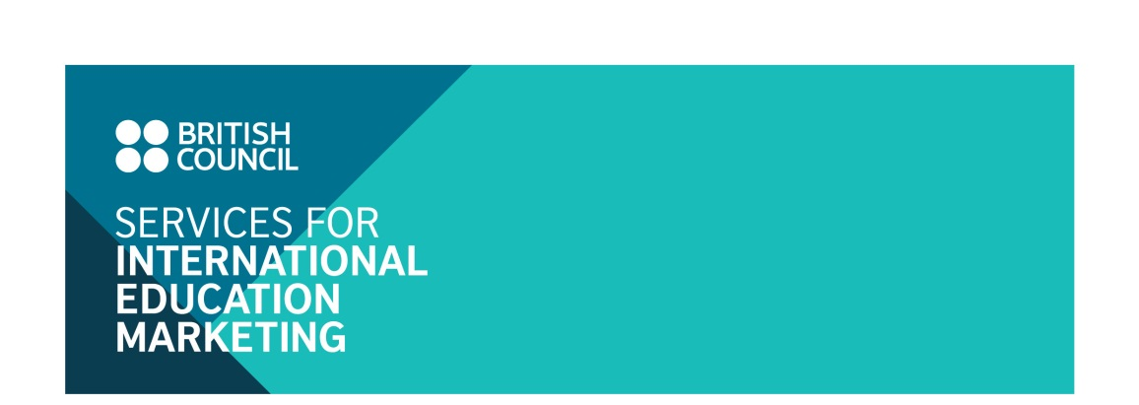UK schools, colleges and   
university pathway programmes  
Marketing Campaign

Application form

**I. UK INSTITUTION DETAILS**

Name of institution:      

Name of contact person:

Contact address:

Tel:

Email:

**II. ADVERTISING PACKAGE AND FEE**

Please indicate your selected advertising option(s), by ticking the relevant box(es)

|  |  |  |
| --- | --- | --- |
| **Package** | **Benefits** | **Participation fee (*)** |
| **1. Digital marketing** | **1. Facebook promotion:**   * 03 posts on the Facebook ‘UK in my eyes’   **2. E-newsletter:**   * 01 advertorial slot on Study UK E-newsletter   **3. Email shot:**   * 02 Email shots sent to British Council student database | GBP 760 |
| **2. Publication** | **1. Print ad:**   * 01 full page institutional profiling page on the booklet *‘Choosing a school and pathway programme in the UK’* | GBP 500 |
| **Institutions can choose to participate in either the Digital Marketing or Publication package or both.** | |  |
| **3. Full package: Digital Marketing + Publication** | | GBP 1,200 |

***Notes:***

* *The above cost is exclusive of UK VAT (20%).*

**III. TOTAL COSTS**

|  |  |  |
| --- | --- | --- |
|  | Subtotal of selected options |  |
|  | Value added tax |  |
|  | **TOTAL** |  |

**IV. UK INSTITUTION DECLARATION**

*I confirm that the above named institution wants to be included in the above selected marketing option(s) with the total cost indicated in section III above.*

*I understand that if this application is accepted, the terms and conditions detailed in the next page will form an agreement between us and the British Council Vietnam.*

Typing your name will be taken as being as your signature.

|  |  |  |  |
| --- | --- | --- | --- |
| Your name |  | Date |  |

The completed application form should be sent electronically by to:

Linh Trinh, Education Marketing Assistant

Email: [linh.trinh@britishcouncil.org.vn](mailto:linh.trinh@britishcouncil.org.vn)

**V. TERMS AND CONDITIONS**

**Acceptance**

The British Council Vietnam reserves the right to accept participating institutions in the relevant advertising options on a first come first served basis until we reach sufficient number of participants for each marketing option.

Applicants will be notified by email of the acceptance within one week as of date of application.

**Payment schedule**

The British Council Vietnam will invoice the participating institution for the cost applicable to the advertising option(s) selected in the previous page.

The term of payment is 30 days of the invoice date. In accordance with British Council audit procedures reminder letters will be issued for all outstanding invoices over 45 days. Until all invoices are cleared, a block will be placed on your British Council account. Further applications to participate in British Council events and other organised programmes of activity cannot be accepted until all outstanding invoices have been paid.

**Cancellation**

Cancellation fees will be charged for withdrawal from the marketing campaign, as of the date of receiving Notice of Withdrawal via email:

* At 50 per cent of the full fee of the selected package(s) for withdrawals received between 15 and 30 December 2017.
* At 100 per cent of the full fee of the selection package(s) for withdrawals received after 2 January 2018.