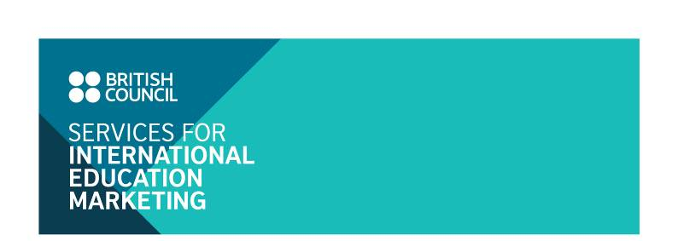
Top Chinese-language annual DSE guide in Hong Kong

Introduction

The 2017 Hong Kong Diploma of Secondary Education Examination (HKDSE) results will be announced on 12 July. The Chinese language newspaper, Sing Tao Daily, will publish a guidebook - HKDSE Guidebook 2017, to provide hints and advice for the graduates this year. Topics in the guidebook to be covered include:

(1) Introduction of further study options, such as bachelor degree, associate degree, higher diploma, overseas studies, vocational training etc.

(2) Profiles of School and education institutes

(3) Interviews with academic professionals and case studies of recent graduates

While the main focus of the newspaper magazine-format guide is universities in Hong Kong, there is useful coverage of overseas options, including the UK. The UK institutions could raise their profile by advertising is this guidebook, which will be published in early July 2017.

Audience Reach

- Circulation: around 20,000
- Free distributed to around 200+ secondary schools on 4 Jul 2017
- Free redemption at Sing Tao centers (central & TST) on 4 Jul 2017
- Free online flipbook on 12 Jul 2017*
- Free apps (android) on 12 Jul 2017*

* Remarks : Digital format subject to Singtao final confirmation

Advertising Rate:

 | Full colour
Full Page  Trim Size: 270mmH x 215mmW  Bleed Size: each side 5mm | GBP 2,150
Half Page  Horizontal:  125mm(H) x 200mm(W)  Vertical:  260mm(H) x 95mm(W) | GBP 1,200
Quarter page  125mm(H) x 95mm(W) | GBP 700

Advertisement Format

Points to note
The rates exclude artwork production. Please follow the specifications below when submitting your artwork file.

Specifications
Size: refer to the above table
Format: ai or psd files (Adobe Illustrator/Photoshop CS5 or lower)
Graphics: Embed all placed or imported images. All images should have a minimum resolution of 350 dpi, tiff file is preferable.
Colour: CMYK
Texts: Convert all fonts to curves or outlines
Proof: We will send a PDF file for your approval. Once the proof is signed off, the order will proceed and no changes can be made.

Submission: By Friday 26 May 2017 by email if the file is less than 10 MB or contact Ivy Leung at ivy.leung@britishcouncil.org.hk
* Sendspace, WeTransfer, Dropbox are welcome.

Advertising opportunity with top Chinese-language DSE guide in Hong Kong

Reply Form:

Name of institution*:______________________________________________________________
(*This format will be used in all publicity)

Main contact:

Telephone:

Fax:

E-mail:

Contact address:

I would like to sign up for:

Sing Tao HKDSE Guidebook 2017

 | Full colour
Full Page | GBP 2,150
Half Page | GBP 1,200
Quarter page | GBP 700

Cancellation deadline

Cancellation fees will be charged for withdrawal as of the date of receipt of notice (by email or in writing):

- At 50 per cent of the full cost, for withdrawals received on or after 12 May 2017
- At 100 per cent of the full cost, for withdrawals received on or after 26 May 2017

DECLARATION

I confirm that the above named organisation does want to partake in advertising in the Sing Tao HKDSE Guidebook 2017. (Options ticked above). I understand that if this application is accepted that the terms and conditions listed below will form a binding contract between this organisation and the British Council.

__________________________________ __________________________________
Signature of applicant Organisation’s stamp

___________________________________
Date:

Please complete the reply form above and return it by 12 May, 2017 to:

Ivy Leung
Education Executive, Services for International Education Marketing
British Council
3 Supreme Court Road
Admiralty, Hong Kong
Email: bc-siem@britishcouncil.org.hk

Terms and conditions:

1. Accredited Institutions
All participating institutions must be accredited by a recognised UK authority, or local partners of recognised UK institutions.

2. Payment schedule
Advertisers will be invoiced by the British Council in Hong Kong. Terms of payment are within thirty days of the invoice date.

3. Acceptance
An acceptance letter will be sent to all applicants once the signed application form is received.

