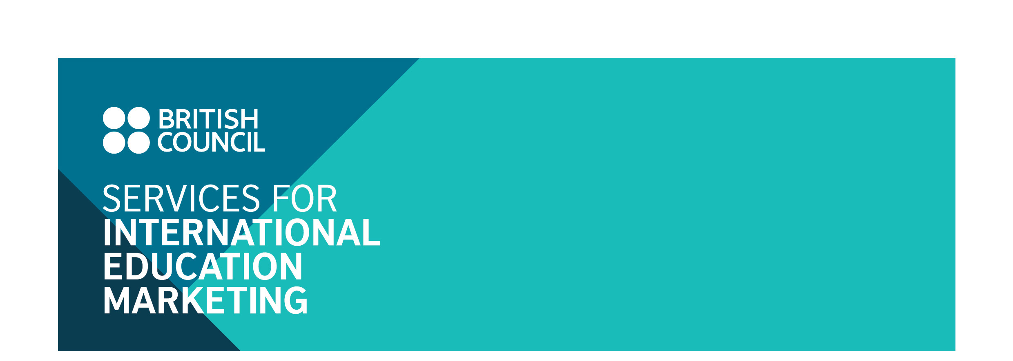
Study in the UK Guide 2017-18 (Hong Kong)
Information and Advertising Booking Form
March 2017
Introduction

We are pleased to inform you that British Council Hong Kong will be producing a Study in the UK Guide for 2017/18, building on the success of previous editions.

The Guide aims to achieve several objectives:
1. To help students in Hong Kong to better understand the study opportunities offered by institutions in the UK;
2. To assist UK institutions to reach out to potential students, in the interests of international student recruitment.

Currently over 22,000 Hong Kong students are studying in the UK, with Hong Kong being the fifth largest non-EU recruitment market for higher education and the second largest market for boarding schools. This Guide will therefore be a much sought after publication, and an essential guide for students looking to commence study in the UK.

- The Guide will include information sections on each level of education – from prep schools to boarding and independent day schools, to further education and university. Advertisements by institutions will feature in relevant sections. In addition, student profile provided will be promoted on British Council Hong Kong FaceBook page.

Audience Reach

The initial print run will be 13,000 copies, and promotion of the guide will be supported by a dedicated advertising campaign. The guide will be distributed by:
- British Council channels such as exhibitions, information seminars, schools roadshow and other events.
- Secondary school career offices.

The online version will be available and promoted via the British Council e-newsletter and direct marketing to opt-in students on British Council’s marketing database. We will also encourage schools to upload the online guide or share the link on their student-facing platform or school’s website.

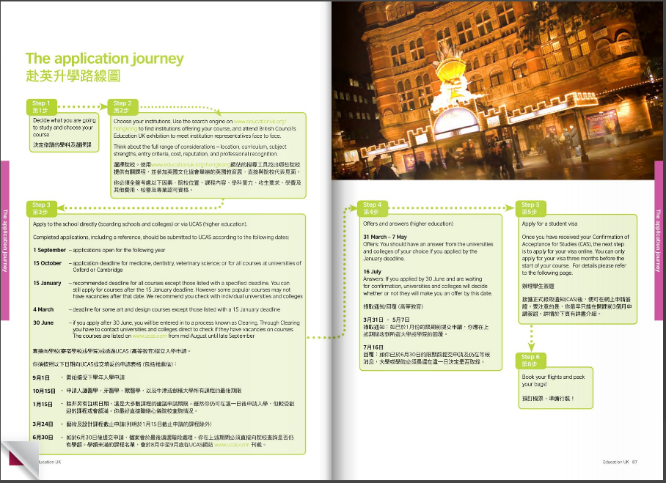
The publication will provide a comprehensive guide for students, including sections on why study in the UK, pre-university pathways, degree options, application processes, costs, adapting to life in the UK and finding employment in Hong Kong upon graduation.

Advertising in the Guide gives you the following:
- One full page advertisement
- One page student profile (current student or alumni or staff).
- The student profile provided will be promoted on British Council Hong Kong FaceBook page

Advertising Rate:

For HE: Advertisement + student/alumni/staff profile (include a Facebook post) GBP1,450 net
For Schools and FE: Advertisement only GBP790 net or
Advertisement + student/alumni/staff profile (include a Facebook post)
GBP1,180 net

You may also consider taking advantage of following prominent space:
Inside back: GBP2,000 net (Inside back cover advert and 1 full page of profile –
include a Facebook post (R.O.P.)
Back cover: GBP2,900 net (Back cover advert and 1 full page of profile -
include a Facebook post (R.O.P.)

To book advertising please complete the reply form and declaration on the following pages.

Cancellation Deadline

Cancellation fees will be charged for withdrawal as of the date of receipt of notice (by email or in writing):
- At 50 per cent of the full cost, for withdrawals received on or after Friday 21 April 2017.
- At 100 per cent of the full cost, for withdrawals received on or after Friday 19 May 2017.

Reply Form:

Name of institution*:
(*This format will be used in all publicity)

Main contact:

Telephone:

Fax:

E-mail:

Contact address:

For HE:

Advertising and student/alumni/staff profile cost - I understand that advertising in the guide will incur a charge of GBP1,450 net.

For Schools and FE:

Advertising cost - I understand that advertising in the guide will incur a charge of GBP790 net.

Advertising and student/alumni/staff profile cost - I understand that advertising in the guide will incur a charge of GBP1,180 net.

Prominent space:

Inside back: Inside back cover advert and 1 full page of profile (R.O.P.) cost - I understand that advertising in the guide will incur a charge of GBP2,000 net.

Back cover: Back cover advert and 1 full page of profile (R.O.P.) cost - I understand that advertising in the guide will incur a charge of GBP2,900 net.

DECLARATION

I confirm that the above named organisation does want to partake in advertising in the Study in the UK Guide. (Options ticked above). I understand that if this application is accepted that the terms and conditions listed below will form a binding contract between this organisation and the British Council.

Signature of applicant |  | Institution’s stamp
Date

Please complete the reply form above and return it to:

Janice Ng
Marketing Services Manager, Education
British Council
3 Supreme Court Road
Admiralty, Hong Kong
Email: bc-siem@britishcouncil.org.hk

Terms and conditions:

1. Accredited Institutions
All participating institutions must be accredited by a recognised UK authority, or local partners of recognised UK institutions.

2. Payment schedule
Advertisers will be invoiced by the British Council in Hong Kong. Terms of payment are within thirty days of the invoice date.

3. Acceptance
An acceptance letter will be sent to all applicants once the signed application form is received.

