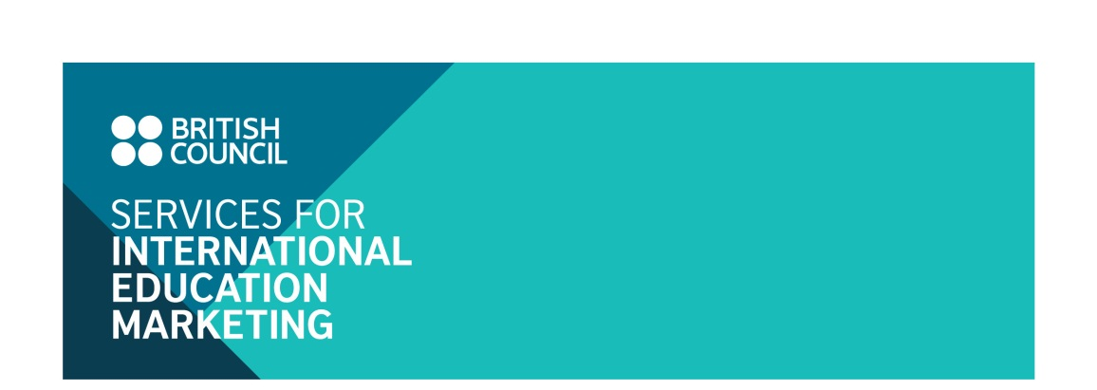UK Independent schools   
marketing programme

Application form

**I. UK INSTITUTION DETAILS**

Name of institution:      

Name of contact person:

Contact address:

Tel:

Email:

**II. ADVERTISING PACKAGE AND FEE**

Please indicate your selected advertising option(s), by ticking the relevant box(es)

|  |  |  |  |
| --- | --- | --- | --- |
| **Package benefits** | | **Individual channel fee** | **Package**  **fee** |
|  | * Participation in 01 Facebook Q & A programme* on the page ‘UK in my eyes’ | £500 | £1,100 |
|  | * Advertisement in 1,000 brochures ‘Why choose a UK independent school’ | £500 |
|  | * 01 email shot | £200 |
|  | * 01 advertorial slot in the monthly Education UK E-newsletter | £500 |

***Notes:***

* *The above cost is exclusive of UK VAT (20%).*
* *Participating schools could choose to participate in the following Facebook Q & A programme. Booking will be accepted on* a first come first served basis:
  + *Friday, 17 February 2017: from 20:00 to 22:00 Vietnam local time.*

**III. TOTAL COSTS**

|  |  |  |
| --- | --- | --- |
|  | Subtotal of selected options |  |
|  | Value added tax |  |
|  | **TOTAL** |  |

**IV. UK INSTITUTION DECLARATION**

*I confirm that the above named institution wants to be included in the above selected marketing option(s) with the total cost indicated in section III above.*

*I understand that if this application is accepted, the terms and conditions detailed in the next page will form an agreement between us and the British Council Vietnam.*

Typing your name will be taken as being as your signature.

|  |  |  |  |
| --- | --- | --- | --- |
| Your name |  | Date |  |

The completed application form should be sent electronically by to:

Binh Do, Education Marketing Officer

Email: [Binh.do@britishcouncil.org.vn](mailto:Binh.do@britishcouncil.org.vn)

**V. TERMS AND CONDITIONS**

**Acceptance**

The British Council Vietnam reserves the right to accept participating institutions in the relevant advertising options on a first come first served basis until we reach sufficient number of participants for each publication.

Applicants will be notified by email of the acceptance within one week as of date of application.

**Payment schedule**

The British Council Vietnam will invoice the participating institution for the cost applicable to the advertising option(s) selected in the previous page.

The term of payment is 30 days of the invoice date. In accordance with British Council audit procedures reminder letters will be issued for all outstanding invoices over 45 days. Until all invoices are cleared, a block will be placed on your British Council account. Further applications to participate in British Council events and other organised programmes of activity cannot be accepted until all outstanding invoices have been paid.

**Cancellation**

Cancellation fees will be charged for withdrawal from the publication, as of the date of receiving Notice of Withdrawal via email:

* At 50 per cent of the full fee of the selected package(s) for withdrawals received between 30 to 15 days prior to the first implementation date.
* At 100 per cent of the full fee of the selection package(s) for withdrawals received after 15 days prior to the first implementation date