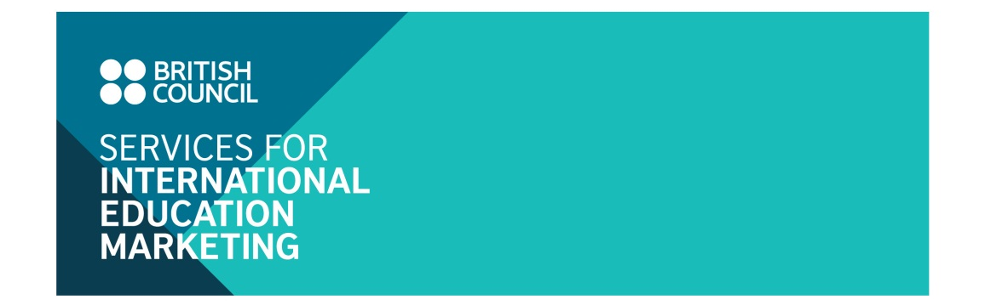
UK independent schools

Marketing campaign

Jan – Mar 2017

- The British Council Vietnam is delighted to invite UK independent schools (both boarding and non-boarding schools) to promote your institutional profiles and courses for Vietnamese students in the ‘UK Independent schools marketing campaign’ which will run from January to March 2017. UK schools participating in the campaign will have a good opportunity to reach a wide target audience via publication advertising and digital marketing channels.
- Vietnam saw a growth of 13.9% in Tier 4 Child visas issued in the first three quarters of this year compared to the same period last year, reflecting a trend that shows growing interest in UK school and pathway programmes (IGCSE, A-level, IB, Foundation…) from prospective students and their parents. In terms of Student Visitor visas, Vietnam has seen a very high growth rate (177%), increasing from 178 Student Visitor visas in the first three quarters of 2015 to 494 for the same period in 2016. It is worth noticing that 87% of the Vietnam Student Visitor visas are Child students, i.e. those who go to the UK for English courses over the summer months.

- Marketing activities
Benefits for participating schools include:
  - Facebook Question and Answer programme:
- Participating schools will have one Facebook Q & A session on the Facebook page ‘UK in my eyes’ (http://www.facebook.com/NuocAnhTrongMatToi). The Facebook Q & A session provides an opportunity for representatives and alumni of participating schools to have direct interaction with prospective students who are members of the Facebook page. Topics focus on courses on offer, quality of teaching, scholarship information, facilities and student care, and student experience of studying at the participating schools.
- The Q&A session is an online event hosted on Facebook ‘UK in my eyes’. Each session is live for two hours and involves up to 5 independent schools. Each participating school will appoint one representative to co-ordinate the event by sending PR content for promotion, answering enquiries from online audiences and inviting their Vietnamese alumni to participate in the event to jointly answer enquiries. In 2015-16, 8 Facebook Q & A sessions were organised which helped UK institutions respond to 251 direct enquiries from participants.
Please visit the link below for information about a Facebook Q & A Session which was organised with the participation of University of South Wales and University of Kent: https://www.facebook.com/events/1036299119782365/?active_tab=discussion
- The Q & A session will be promoted widely on British Council communication channels 10 days before the event:
  - British Council Vietnam website: The names of participating schools are published on the British Council Vietnam website (~ 5,840 visitors/day, ~ 175,200 visitors/month);
  - Facebook ‘UK in my eyes’ (www.facebook.com/NuocAnhTrongMatToi): Profiles of participating schools are posted on Facebook ‘UK in my eyes’ (>82,000 members) to promote the Q & A session.
- The programme is organised in the third weeks of January or February 2017.

1.2. Advertisement in the brochure ‘Why choose a UK independent school’
- Profiles of participating UK schools are advertised in the brochure ‘Why choose a UK independent school’. This brochure will be produced & distributed to students who visit the Study UK - Discover You Exhibition & Roadshow in Hanoi, Hai Phong and Ho Chi Minh City in March 2017.
- Quantity of brochures: 1,000 copies
- Main content of brochure:
  - Choosing a school
  - Entrance
  - Quality assurance
  - Welfare
  - Where can I find more information?
  - Advertorials from UK Independent schools
1.3. Digital marketing activities:
UK participating schools will be promoted through the digital marketing channels of the British Council as follows:
  - Email marketing: An email shot promoting the school profile, courses, scholarship offe, etc. will be sent to 300 students who have expressed an interest in pre-university courses in the UK;
  - Monthly E-newsletters: An advertorial slot in the Education UK E-newsletter (sent to a database of 8,000 prospective student emails) will be provided. There will be 3 Education UK E-newsletters sent out in January, February and March.
- Advertising Package and Fee
Advertising benefits | Individual channel fee | Package fee
Participation in 01 Q & A programme on Facebook page ‘UK in my eyes’ (https//facebook.com/NuocAnhTrongMatToi) | 500 | GBP 1,100
Advertisement in the brochure ‘Why choose a UK independent school’ | 500 | GBP 1,100
01 email shot | 200 | GBP 1,100
01 advertorial slot in monthly Education UK E-newsletter | 500 | GBP 1,100
Additional benefits:
• FREE translation, edit of the PR/advertising content by the British Council
Note:
  - The above rate is exclusive of 20% UK VAT
- Application
Please send your expression of interest to Mr Binh Do, Education Marketing Officer at binh.do@britishcouncil.org.vn by 20 January 2017.

