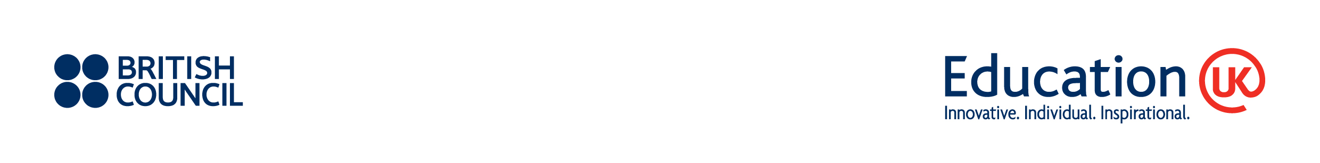
Please complete the form and send as a scanned PDF file to
JP_BC-SIEM@britishcouncil.org by 8th January 2016.

Education UK English Language Study Guidebook
Name of institution:

Authorised person: | Name |  | Signature
 | Tel: | Fax:
 | Email:
- Please check this box if your institution meets the eligibility criteria.
(English language school in the UK that is either accredited by Accreditation UK or listed on the UK Visas and Immigration of Tier 4 Sponsors)

I would like to place an advertisement / school profile in the Education UK English Language Study Guidebook produced by the British Council in Japan. I am aware of the fee as stated below.
Position (please tick one box) | Price* | Remark
□ Inside front cover | £600 | Additional profile page provided within guidebook
□ Inside back cover | £500 | Additional profile page provided within guidebook
□Back cover | £700 | Additional profile page provided within guidebook
□ 1 Profile page in Japanese  • School name, logo, and contact details  • Brief information about the school (up to 700 words)  • Tuition fees  • Up to three photographs of the school  • A map of the UK to show the location of the school (prepared by the British Council)  • Name of Japanese agents handling your courses as of March 2016 (optional)  Institutions will be asked to complete a template. The contents will be translated into Japanese and the artwork prepared by the British Council. | £400 | Translation fee and artwork included
*Excluding applicable VAT.

