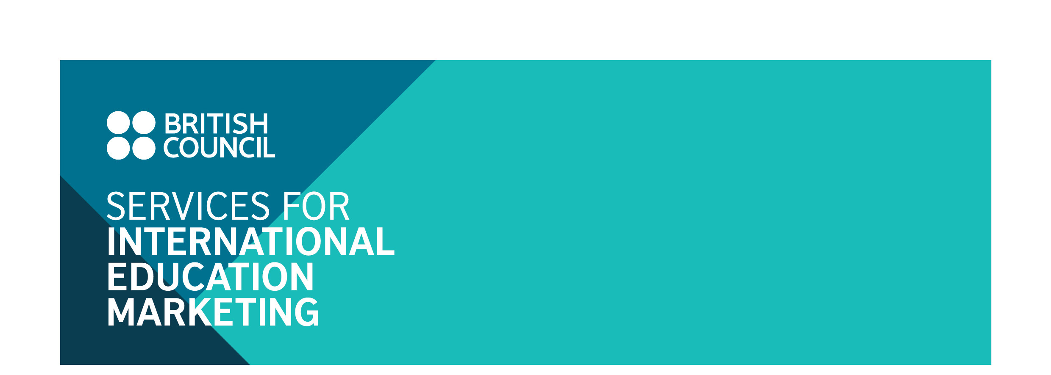
Study in the UK Guide (Hong Kong)

Information and Advertising Booking Form

27 January 2015

Introduction

We are pleased to inform you that British Council Hong Kong will be producing a Study in the UK Guide for 2015/16, building on the success of last year’s Guide.

The Guide aims to achieve several objectives:

1. To help students in Hong Kong to better understand the study opportunities offered by institutions in the UK;
2. To assist UK institutions to reach out to potential students, in the interests of international student recruitment.

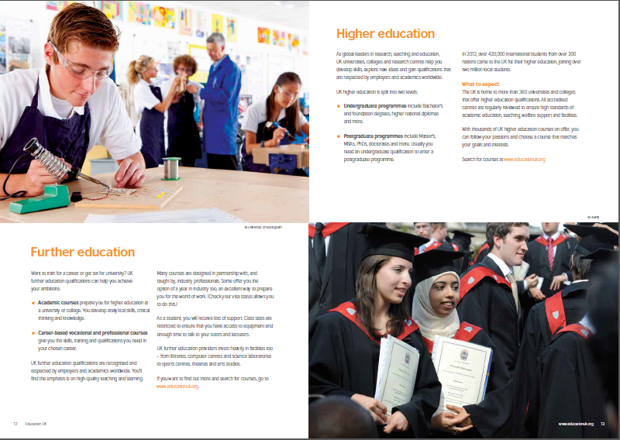
Currently around 17,500 Hong Kong students are studying in the UK, with Hong Kong being the sixth largest recruitment market for undergraduate level courses and the second largest market for boarding schools. This Guide will therefore be a much sought after publication, and an essential guide for students looking to commence study in the UK.

The Guide will include information sections on each level of education – from prep schools to boarding and independent day schools, to further education and university. Advertisements by institutions will feature in relevant sections.

Audience Reach

The initial print run will be 15,000 copies, and promotion of the guide will be supported by a dedicated advertising campaign. The guide will be distributed by:

- British Council channels such as exhibitions, information seminars, schools roadshow and other events.
- Secondary school career offices.

The online version will be available and promoted via the British Council e-newsletter and Direct Marketing to opt-in students on British Council’s marketing database.

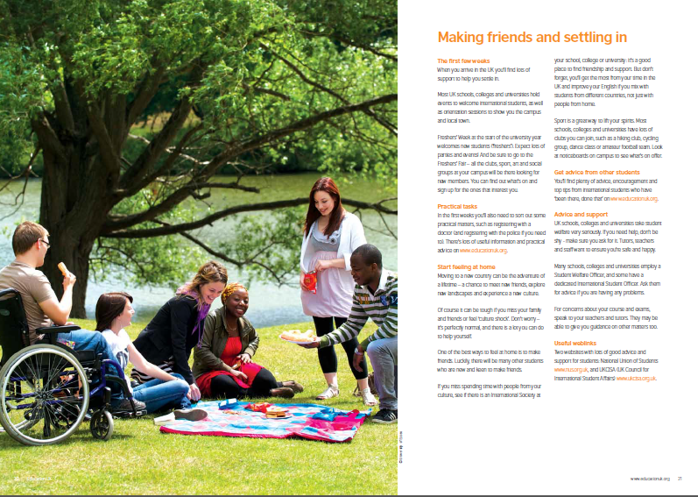
The publication will provide a comprehensive guide for students, including sections on why study in the UK, pre-university pathways, degree options, application processes, costs, adapting to life in the UK and finding employment in Hong Kong upon graduation.

Advertising in the Guide gives you the following:

- One full page advertisement
- One page student profile (current student or alumni)

Advertising Rate:

For HE: Advertisement + student/alumni/staff profile GBP 1,150
For Schools and FE: ‘Advertisement only’ GBP 650 or
‘Advertisement + student/alumni/staff profile’ GBP 980
Back cover GBP 2,500; inside front GBP 1,650; inside back GBP 1,650

To book advertising please complete the reply form and declaration on the following pages.

Cancellation deadline

Cancellation fees will be charged for withdrawal as of the date of receipt of notice (by email or in writing):
- At 50 per cent of the full cost, for withdrawals received on or after 27 March 2015.
- At 100 per cent of the full cost, for withdrawals received on or after 17 April 2015.
Reply Form:

Name of institution*:______________________________________________________________
(*This format will be used in all publicity)

Main contact:

Telephone:

Fax:

E-mail:

Contact address:

For HE:

Advertising and student/alumni/staff profile cost - I understand that advertising in the guide will incur a charge of GBP 1,150.

For Schools and FE:

Advertising cost - I understand that advertising in the guide will incur a charge of GBP 650.

Advertising and student/alumni/staff profile cost - I understand that advertising in the guide will incur a charge of GBP 980.

Other options:

Back cover (optional and depending on availability) - I understand that selecting the back cover incurs a charge of GBP 2,500.

Inside front (optional and depending on availability) - I understand that selecting the inside front incurs a charge of GBP 1,650;

Inside back (optional and depending on availability) - I understand that selecting the inside back incurs a charge of GBP 1,650

DECLARATION

I confirm that the above named organisation does want to partake in advertising in the Study in the UK Guide. (Options ticked above). I understand that if this application is accepted that the terms and conditions listed below will form a binding contract between this organisation and the British Council.

__________________________________ __________________________________
Signature of applicant Organisation’s stamp

___________________________________
Date

Please complete the reply form above and return it to:

Steve Corry
Regional Business Development Manager
British Council
3 Supreme Court Road
Admiralty, Hong Kong
Email: bc-siem@britishcouncil.org.hk

Terms and conditions:

1. Accredited Institutions

All participating institutions must be accredited by a recognised UK authority, or local partners of recognised UK institutions.

2. Payment schedule

Advertisers will be invoiced by the British Council in Hong Kong. Terms of payment are within thirty days of the invoice date.

3. Acceptance

An acceptance letter will be sent to all applicants once the signed application form is received.

