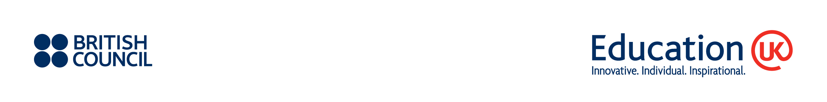
UK Art and Design Courses Booklet Application Form

Name of institution:
(This format will be used in all publicity)

Main contact:

Telephone:

Fax:

E-mail:

Postal address:

Please tick the appropriate box for your institution:

Item | Quotation | Please  select
Profile listing  (Full page of A5 size) | GBP 500 *
Advertorial page on the inside front cover OR the inside back cover (Full page of A5 size) | GBP 800 *
* All prices are exclusive of VAT unless otherwise stated
License number
by UKBA

Cancellation deadline
Cancellation fees will be charged for withdrawal from the publication, as of the date of receipt of Notice of Withdrawal:
- 50 per cent of the full advertisement fee for withdrawals received on or after 22 June 2012.
- 100 per cent of the full advertisement fee for withdrawals received on or after 27 July 2012.

I confirm that the above named organisation wants to be included in the Art and Design courses booklet. I understand that if this application is accepted that the enclosed terms for British Council Services for International Education Marketing will form a binding contract between this organisation and the British Council.

Signed by the duly authorised representative of the institution:
Name: |  | Signature:
Position: |  | Date:

