Bringing Students Together!
UK Student Mobility Awards 2014

British Council Korea is launching the 2014 UK Student Mobility Awards to encourage two-way mobility between Korea and the UK. In assistance with British Airways and Incheon International Relations Foundation (IIRF), we will provide a round trip airfare and organize cultural events for ten selected British students whose studies start between April and December 2014. For more details about the Awards, please refer to the following.

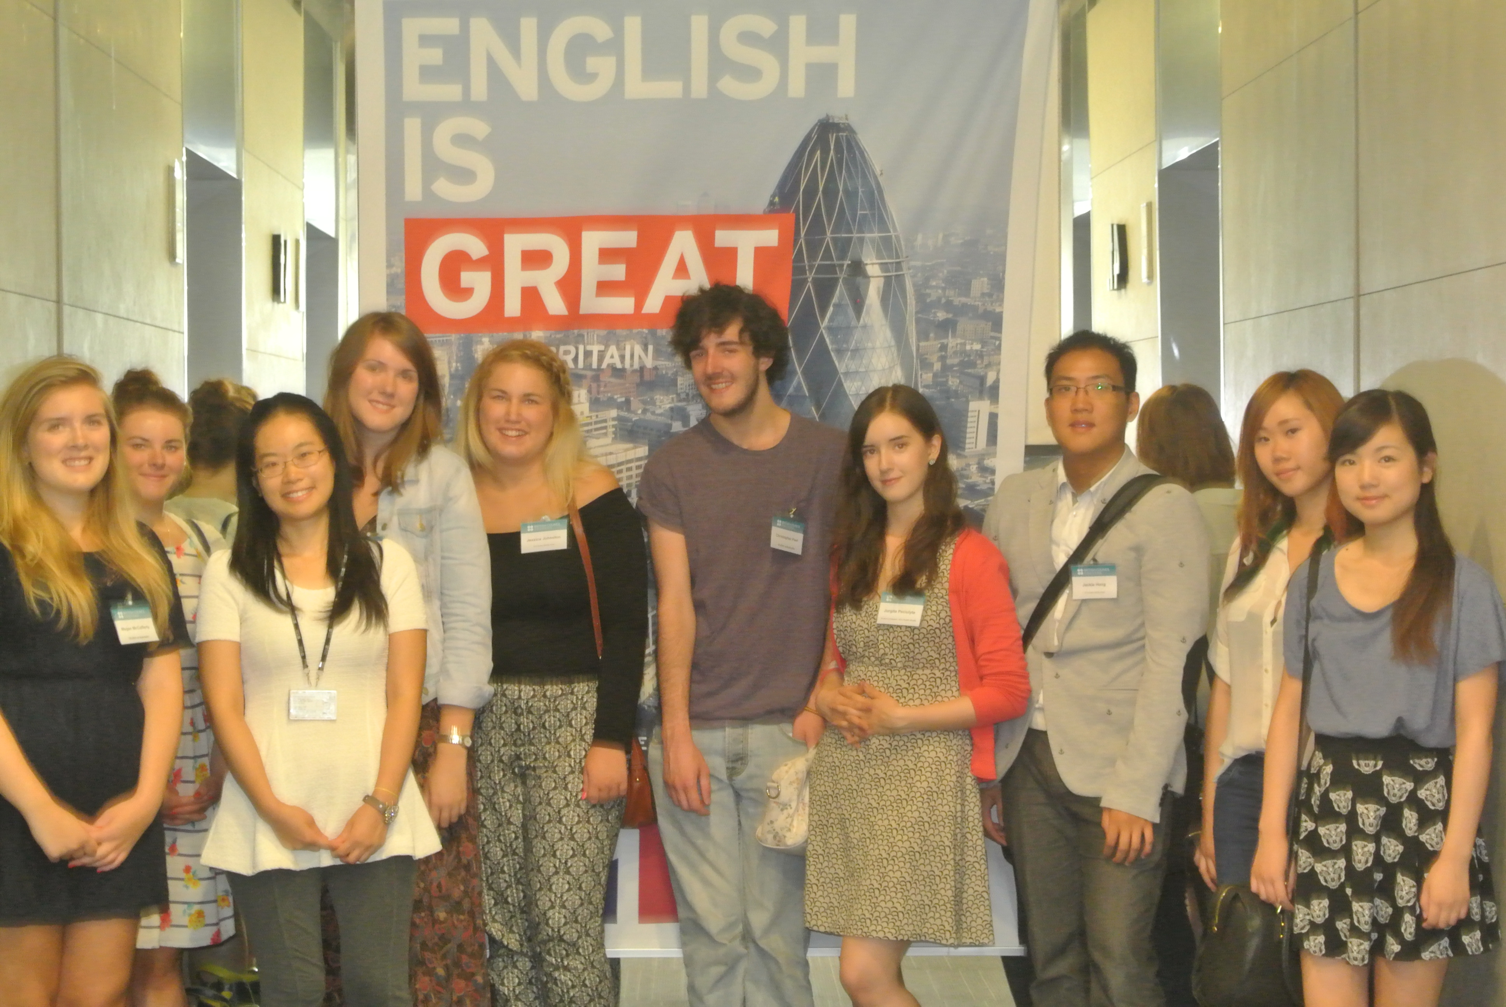
Student mobility event on 14 September 2013 © British Council Korea

Who benefits?
Ten students will be awarded a round trip airfare to the value of £1,200, up to a maximum of three students per institution. Students’ studies may include a summer school, a term exchange, a year exchange and a full degree study but not a short exploratory visit.

Award recipients are expected to act as student ambassadors for the UK, and also share their studies and life experiences, with other interested British students on British Council Korea micro social network sites, during their study in Korea. Students will also be invited to a couple of UK-Korea student networking events and cultural events whilst here in Korea. As a part of cultural activities, student ambassadors are cordially invited to the three days’ cultural tour to Incheon by Incheon International Relations Foundation (IIRF). Date will be advised by successful candidates.

Who can apply?
Institutions that have developed student exchange agreements with Korean universities or colleges and are scheduled to dispatch their students to their Korean partner institutions between April and December 2014. Students are the recipients of the award but their institution should apply on behalf of them for the award.

Interested institutions should submit their completed application forms to Joohee Ban, Education Intelligence & Partnerships Manager (Joohee.Ban@britishcouncil.or.kr) by Friday 7 February 2014.

How it works
- Application deadline: Friday 7 February 2014
- Application evaluation: 10 February - 19 February 2014
- Announcement of successful applications: Thursday 20 February 2014

Please be advised that only successful applicants will be contacted individually. Further instructions will be issued afterwards.

Contact at British Council Korea
Joohee Ban, Education Intelligence & Partnerships Manager
E Joohee.ban@britishcouncil.or.kr
T +82 (0)2 3702 0627

Application Form

Institution
Name/title
Contact details | Email
Contact details | Phone

Description of the partnership
Partner institution
Contact at partner institution (name/title)
Please briefly describe your partnership in terms of history, impact and sustainability

Student inforamtion
Student 1 details
Name
Department/subject
Study period /type
(starting from)
Student 2 details
Name
Department/subject
Study period/type
(starting from)
Student 3 details
Name
Department/subject
Study period/type
(starting from)

Date of submission
Submitted by

